 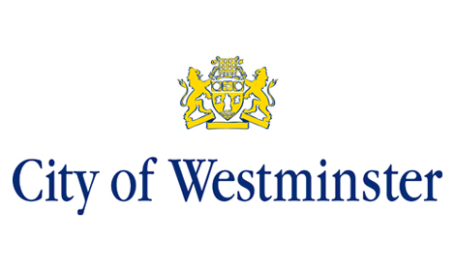 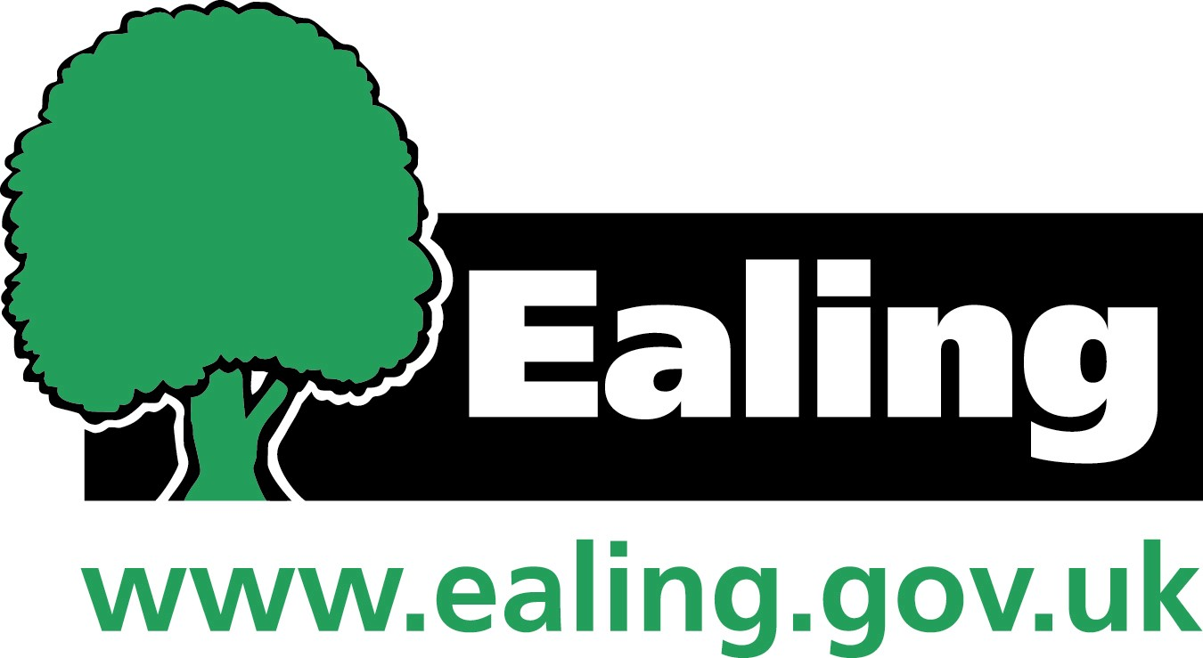  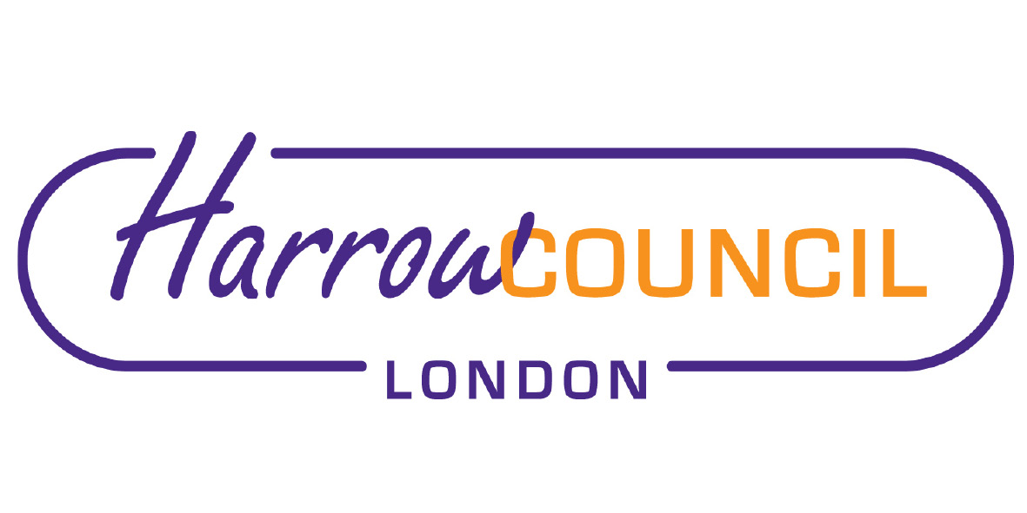  

**North West London**

**Clinical Commissioning Groups**

**Children and Young People’s Mental Health and Wellbeing Local Transformation Plan 2015-2020**

October 2019 Refresh



**Declarations of Support**

**Brent**

|  |  |
| --- | --- |
| Name:  Position/Organisation:    Date: | Name:  Position/Organisation:  Date: |

**Central London**

|  |  |
| --- | --- |
| Name:  Position/Organisation:  Date: | Name:  Position/Organisation:  Date |

**Ealing**

|  |  |
| --- | --- |
| Name:  Position/Organisation:  Date: | Name:  Position/Organisation:  Date: |

**Hammersmith and Fulham**

|  |  |
| --- | --- |
| Name:  Position/Organisation:  Date: | Name:  Position/Organisation:  Date: |

**Harrow**

|  |  |
| --- | --- |
| Name:  Position/Organisation:  Date: | Name:  Position/Organisation: Chair  Date: |

**Hillingdon**

|  |  |
| --- | --- |
| Name:  Position/Organisation:  Date: | Name:  Position/Organisation:  Date: |

**Hounslow**

|  |  |
| --- | --- |
| Name:  Position/Organisation:  Date: | Name: Councillor  Position/Organisation:  Date: |

**West London**

|  |  |
| --- | --- |
| Name:  Position/Organisation: :  Date: | Name:  Position/Organisation:  Date: |

Contents

1.0 Executive Summary 5

2.0 Our Ambition and Vision for the Future 7

3.0 Understanding Local Need 9

4.0 Service Provision 14

Child and Adolescent Mental Health Services 14

The Specialist Eating Disorder Services 14

Crisis and Urgent Care and Community Outreach Services 14

Early Intervention in Psychosis Services 14

Paediatric Liaison Psychology Services 15

Specialist Learning Disability Services- 15

Specialist Autism Services 15

Looked After Children Services 15

Youth Offender/Justice Services 15

NW London Child Sexual Assault Hub 16

5.0 NW London Shared Priorities 17

5.1 Priority One: Access and Waiting Times 18

5.2 Priority Two: Community Eating Disorders (ED) Service 22

5.3 Priority Three: Redesigning the System 27

5.4 Priority Four: Vulnerable Groups 31

5.5 Priority Five: Integrated Crisis and Urgent Care Pathway 40

Collaborative Commissioning- New Models of Care 43

Collaborative Commissioning: Lavender Walk Provision of Tier 4 Beds 44

Health Based Places of Safety 45

Beyond Places of Safety 45

6. Enablers 48

6.1 Enabler One: Co-production 48

6.2 Enabler Two: Workforce Development 49

6.3 Enabler Three: Performance Monitoring and Reporting 52

7. Governance and Risks 53

8. Risk Management 55

9. Local Annexes 57

# 1.0 Executive Summary

This document is the third annual refresh of the 2015-2020 North West London (NW London) Children and Young People’s (CYP) Mental Health and Wellbeing Local Transformation Plan (LTP). The original plan, which was approved by NHS England in 2015, presented a comprehensive review of local arrangements and set out ambitious plans for the system-wide transformation of services.

This refreshed plan builds on the progress made in previous years; it outlines ongoing plans to affect whole system change, address gaps in provision that remain and any emerging areas of need.

Our ambition has been to ensure, by 2021, that every CYP in NW London can access appropriate needs based, person centred mental health support that significantly improves outcomes. We have set up our CYP mental health programme to drive transformation and help make this vision a reality. The programme forms a key component of the mental health work that is being undertaken within the NW London Health and Care Partnership. The work has been guided by the *North West London Sustainability and Transformation Plan[1]* and, as we move forwards, will reflect the commitments for mental health set out in the NHS Long Term Plan[2]*.* Our transformation programme is underpinned by commitment and agreed priorities by our partners and board members, and supported through key enablers, such as workforce development and performance monitoring. Co-production is at the heart of our programme and ensures that CYP and their families are central to the design and development of pathways and services. We are cognisant that service redesign also requires adoption of a wider co-production approach, therefore regular events, group discussions and other engagement activities have been organised to bring together professionals from health, social care, education and the voluntary sector to discuss system level issues and mobilise plans to address these.

Over the last twelve months we have capitalised and consolidated on our learning and worked closely with our providers and Specialised Commissioning to improve our services. Our third year of transformation has seen sustained delivery of real improvements including:

* Increased numbers of CYP accessing the appropriate evidence based treatment to aid their recovery;
* Reduction in waiting times for treatment, providing more timely interventions to help minimise escalation of needs;
* Providing better crisis care in the community, preventing admissions to hospitals and facilitating discharge of CYP to return home at the earliest opportunity;
* All but one of our CCGs are meeting the one-week wait time target for urgent referral to CYP eating disorder services, and there has been sustained improvement in four-week wait times over the past year;
* We have worked with CYP to develop and implement a comprehensive plan to transform mental health services, working across health, care, education and the justice system;
* Strengthened the relationship between education and mental health services through the rollout of CYP trailblazers in West London and Hounslow in 2018/19;
* Through participation in the CAMHS New Models of Care (NMoC) pilot over the past two years, our provider collaborative has succeeded in reducing average length of stay and keeping CYP closer to home reducing out of area bed days by almost 50%.

Over the coming years, there is enormous opportunity to build on this progress through implementation of the NHS Long Term Plan. This will support us to direct our attention to new areas of improvement and better meet the needs of under-represented and vulnerable groups.

What we plan to do next includes:

* The expansion of access to community mental health services (in part delivered by schools based mental health support teams (MHSTs);
* Rollout of MHSTs in schools across Ealing, Central London, Hammersmith & Fulham and the expansion of teams in Hounslow;
* Development and implementation of a comprehensive model of care to support seamless transitions for CYP moving to adult mental health services;
* Ensuring 24/7 access to crisis care via the NHS 111 single point of access;
* Development work on CYP eating disorder services, to ensure that children are provided with a consistent offer across the locality;
* Harnessing digital transformation to further improve access to CYP mental health services;
* Aligning our mental health plans are with those for physical health needs, CYP with a learning disability and/or autism, and other vulnerable groups to improve access, outcomes and ensure a strong start in life for CYP across NW London.

We acknowledge that whilst a substantial amount of work has been undertaken and significant progress has been made with the ongoing implementation of NW London’s LTP, there is still some way to go to address long-standing issues. We remain committed to having robust place-based services and a whole system approach to meeting the emotional and mental health needs of CYP in NW London. This refreshed LTP aims to provide detailed assurance to local and national stakeholders that – working in partnership across health, local authorities, education, and the voluntary sector – we are moving to close remaining gaps and provide care that is inclusive and reflective of our strengths and communities. Leveraging the increasingly strong commitment reflected in the NHS Long Term Plan, we will do this by championing that: mental health is everybody’s business; and the emotional and mental health needs of CYP must remain a core priority for all partners.

# 2.0 Our Ambition and Vision for the Future

Our 2015-20 LTP set out a bold ambition for change for NW London CYP. We wanted to resist being constrained by traditional boundaries – tiers, organisations, funding mechanisms and criteria – and develop clear, coordinated, whole system pathways that improve joint working between agencies and stop young people falling through the gaps.

Building on the findings from engagement with CYP, parents and professionals and a review of our needs assessment, we have refreshed our commitments and ambitions.

Across NW London, we have adopted the ‘THRIVE Model’ to help transform our services. We have agreed to adopt a collaborative approach to developing specialised interventions (getting more help and risk support) whilst also continuing to keep a local focus on developing earlier interventions (getting advice and getting help). Commissioners will continue to collaborate where joint approach will improve provision, deliver system efficiency and provide greater equity of access to good services across the footprint. This will help ensure sustainability through combining resources and joint planning.

We want to continue our drive towards a mental health system without tiers, which is integrated across health, social care and education. We want to further engage with local education partners in developing plans together for how we can best support the emotional wellbeing, resilience and mental health of CYP.

The Like Minded Case for Change[3], published in 2015, set the direction for improving the mental health and wellbeing of our population, and established our collaborative approach to local work. The Like Minded Programme has brought together commissioners, clinicians, local authority partners, providers and experts by experience (through our co-production partners, the Making a Difference Alliance (MADAL)) to drive improvements in care and outcomes for CYP with mental health needs.

Looking forward, we are committed to reflecting the views of our local stakeholders in our work.

As we move forward, we will continue to focus on:

* Building stronger relationships with schools and mobilising resources to offer robust prevention and early intervention initiatives;
* Reviewing the role of technology to improve access to and experience of services for CYP and families;
* Improving access to, and waiting times for treatment and reducing variation across NW London;
* Achieving better integration between initiatives so that CYP can access care that meets their needs in a location as close to home as possible;
* Delivering crisis care in the community, prevention of admissions to hospitals and facilitating discharge of CYP home at the earliest opportunity;
* Establishing principles and reviewing local plans for shifting settings of care, and providing services in communities rather than hospitals.

# 3.0 Understanding Local Need

We know that 50% of all mental health problems manifest by the age of 14, and 75% are present by the age of 24. There are just over 460,000 CYP living in NW London. Locally, 32,287 CYP aged between 5 and 19 years have a mental health disorder and 4,811 have three or more mental health conditions.

The development of the original 2015-16 LTP and the subsequent refreshed plans have been informed by the needs of CYP and their families, building on local Joint Strategic Needs Assessments (JSNAs), population and prevalence data and the Anna Freud Centre needs analysis work.

The NW London CYP population is set out in the table below. For six of our eight boroughs, the boundaries are coterminous between the CCG and local authority. For the other two: West London CCG covers the borough of Kensington and Chelsea, and the Queens Park and Paddington areas of Westminster; and Central London CCG covers the remainder of Westminster.

NWL School Age CYP Population

|  |  |  |  |  |  |  |  |  |  |
| --- | --- | --- | --- | --- | --- | --- | --- | --- | --- |
| **NWL Children and Young People School Age Population[4]** | | | | | | | | | |
|  | **Brent** | **Ealing** | **H&F** | **Harrow** | **H’don** | **H’slow** | **West London** | **Central London** | **Total NWL** |
| 2017 | 51,308 | 59,339 | 27,595 | 40,266 | 56,276 | 45,706 | 25,470 | 31,830 | **337,790** |
| % increase/  decrease | -0.3% | 0.4% | -0.2% | 2.5% | 0.1% | 2.2% | 0.3% | 0.9% | **0.7%** |
| 2018 | 51,167 | 59,583 | 27,532 | 41,251 | 56,316 | 46,727 | 25,550 | 32,102 | **340,228** |

Fourteen percent of the NW London population is aged under 18. This is lower than both the London (18%) and England (17%) average.[5] The number of children attending schools in NW London has slightly increased from 2017 to 2018; noticeable increases were seen in Harrow, Hounslow and Central London CCGs and a reduction in the number of school aged children was seen in Brent and Hammersmith & Fulham CCGs in 2018. Ealing has the highest number of school aged children, accounting for 18% of all NW London children.

Prevalence of Mental Health and Emotional Wellbeing Issues

The table below demonstrates the estimated prevalence of mental health disorders in CYP in NW London. Prevalence is variable: two boroughs are in line with the national and London average (Hillingdon and Hounslow); three significantly lower (West London, Harrow and Hammersmith and Fulham); and three with higher prevalence rates (Brent, Ealing and Central London). In comparison to the London and the national average the prevalence of: emotional disorders is slightly higher in Brent and Westminster; conduct disorders is higher in Brent and Ealing; and hyperkinetic disorders is higher in Brent, Ealing, Hillingdon and Hounslow.

|  |  |  |  |  |  |  |  |  |  |
| --- | --- | --- | --- | --- | --- | --- | --- | --- | --- |
| **Estimated Numbers of Mental Health Disorders (Public Health England**4**)** | | | | | | | | | |
|  | **Brent** | **Ealing** | **H&F** | **Harrow** | **H’don** | **H’slow** | **West London** | **Central London** | **TOTAL NWL** |
| Any mental health Disorders | 4,638 | 4,767 | 1,888 | 3,187 | 4,108 | 3,534 | 2,320 | 1,721 | **26,163** |
| Emotional Disorders | 1,783 | 1,841 | 745 | 1,237 | 1,576 | 1,347 | 920 | 687 | **10,136** |
| Conduct Disorders | 2,885 | 2,924 | 1,140 | 1,920 | 2,503 | 2,164 | 1,395 | 1,047 | **15,978** |
| Hyperkinetic Disorders | 787 | 797 | 307 | 521 | 687 | 595 | 376 | 280 | **4,350** |

Admission Rates

Since 2014/15, admission rates for mental health disorders have declined both nationally and in London. NW London has followed this trend with a decline in admissions in seven of the eight boroughs since 2014/15. Admission rates for the same period have increased in Harrow. Additionally, rates in West London and Hillingdon increased from 2016/17 to 2017/18. There is clear evidence that the newly commissioned crisis pathway and the NMoC pilot have been effective in helping to reduce admissions.

|  |  |  |  |  |  |  |  |  |
| --- | --- | --- | --- | --- | --- | --- | --- | --- |
| **Inpatient admission rate for mental health disorders per 100,00 population aged 0-17[6]** | | | | | | | | |
|  | **Central London** | **West London** | **H’don** | **Brent** | **Harrow** | **H&F** | **Ealing** | **H’slow** |
| 2014/15 | 68.8 | 100.8 | 82.4 | 94.6 | 61.8 | 124.3 | 66.0 | 71.5 |
| 2015/16 | 51.6 | 74.1 | 84.9 | 84.0 | 66.7 | 81.8 | 76.3 | 70.3 |
| 2016/17 | 47.5 | 56.0 | 50.0 | 67.9 | 83.7 | 116.8 | 69.6 | 55.0 |
| 2017/18 | 42.1 | 59.7 | 63.2 | 40.0 | 79.6 | 97.4 | 37.9 | 48.5 |

Self-Harm

Self-harm is one of the most common reasons for presentation at emergency departments and inpatient admissions**[7]** for young people aged 10-25. It is more common in young people with mental health needs, with high rates reported in individuals who have borderline personality disorder, depression and eating disorders.[8]

Data shows an increase of 13% in the number of self-harm hospital admissions for children aged 10-24 across NW London as a whole in 2017/18, compared to the previous year. The rise appears to be driven by increased admissions in Brent, Hammersmith & Fulham, Harrow, Hillingdon, and Hounslow, and to a lesser extent, Central London. The boroughs of Ealing and West London have reported decreased self-harm admission rates in the same period.

|  |  |  |  |  |  |  |  |  |  |
| --- | --- | --- | --- | --- | --- | --- | --- | --- | --- |
| **Self-Harm Hospital Admissions (10-24 year olds per 100,000 population)** | | | | | | | | | |
|  | **Brent** | **Ealing** | **H&F** | **Harrow** | **H’don** | **H’slow** | **WL CCG** | **CL CCG** | **TOTAL NWL** |
| **2014/15** | 63 | 146 | 51 | 74 | 134 | 136 | 43 | 40 | **687** |
| **2016/17** | 62 | 154 | 44 | 50 | 80 | 128 | 42 | 51 | **611** |
| **% change** | 2% | -5% | 14% | 32% | 40% | 6% | 2% | -28% | **11%** |
| **2017/18** | 80 | 105 | 67 | 81 | 108 | 157 | 37 | 58 | **693** |
| **% change** | 29% | -32% | 52% | 62% | 35% | 23% | -12% | 13% | **13%** |

Looked After Children

The number of looked after children (LAC) varies across NW London, with the majority of boroughs having a lower number of LAC than the national and London averages of 64 and 49 per 100,000, respectively (2017/18). The exception is Hammersmith and Fulham, which has 64 LAC per 100,000.

|  |  |  |  |  |  |  |  |  |  |  |
| --- | --- | --- | --- | --- | --- | --- | --- | --- | --- | --- |
| **Number of Looked After Children (per 100,000)** | | | | | | | | | | |
|  | **Brent** | **Ealing** | **H&F** | **Harrow** | | **H’don** | **H’slow** | **West London** | **Central London** | **NW London average** |
| 2015/16  <18 years | 45 | 46 | 58 | 32 | | 49 | 45 | 37 | 39 | **44** |
| **England rate in 2015/16= 60; London rate in 2015/16= 51 (per 10,000 children under 18 years)** | | | | | | | | | | |
| 2016/17  < 18 years | 42 | 42 | 61 | | 36 | 43 | 39 | 28 | 41 | **42** |
| **England rate in 2016/17= 62; London rate in 2016/17= 50 (per 10,000 children under 18 years)** | | | | | | | | | | |
| |  |  |  |  |  |  |  |  |  |  | | --- | --- | --- | --- | --- | --- | --- | --- | --- | --- | | 2017/18  < 18 years | 41 | 42 | 64 | 27 | 40 | 39 | 31 | 45 | **48** | | **England rate in 2017/18= 64; London rate in 2016/17= 49 (per 10,000 children under 18 years)** | | | | | | | | | | | | | | | | | | | | |
| **% of Looked After Children where there is a cause for concern[9]** | | | | | | | | | | |
|  | **Brent** | **Ealing** | **H&F** | | **Harrow** | **H’don** | **H’slow** | **West London** | **Central London** | **NW London average** |
| 2015/16 | 44.7 | 25.7 | 20.9 | | 40.7 | 32.8 | 43.2 | 31.4 | 27 | 33**.3** |
| **England rate in 2015/16= 37.8%; London rate in 2015/16= 32.9%** | | | | | | | | | | |
| 2016/17 | 62.4 | 30.5 | 29.0 | | 29.4 | 25.8 | 34.7 | No data | 25.0 | **33.8** |
| **England rate in 2016/17= 38.1%; London rate in 2016/17= 35.5%** | | | | | | | | | | |

National research has found that among LAC, 38%-49% of children (depending on age) have a mental health disorder. The number of LAC where there is a cause for concern is significantly higher than the national and London average in Brent – Brent has the highest proportion of LAC where there is a cause for concern out of all the London boroughs. Significant reductions in the proportion of LAC where there is a cause for concern have been observed in Harrow, Hillingdon and Hounslow between 2015/16 and 2016/17.

Children with Special Educational Needs

Children with special educational needs may be at higher risk of developing emotional and mental health issues. Across NW London, the percentage of school aged children with special educational needs (SEN), including autistic spectrum disorders, ranges widely (as demonstrated in the table below). The reported proportion of school aged pupils with SEN decreased across NW London in 2018/19. However, the proportion of school pupils with SEN is higher than the London and national average in Hounslow and Central London.

When looking at the primary need of children with SEN in state funded primary schools in 2019, Hillingdon and West London have a higher prevalence of children with autism than the national and London average. The percentage of children that have autism as their primary care need has increased in all NW London boroughs, with the exception of Harrow where the rate has remained unchanged from 2018 to 2019.

There has been decrease in the number of children with moderate learning disabilities as their primary care need across all boroughs (with the exception of Hillingdon), from 2018 to 2019. This has been particularly significant in Brent and West London with a decrease of 18% and 26% respectively.

|  |  |  |  |  |  |  |  |  |  |  |
| --- | --- | --- | --- | --- | --- | --- | --- | --- | --- | --- |
| **Children with Special Education Needs[10]** | | | | | | | | | | |
|  | | **Brent** | **Ealing** | **H&F** | **Harrow** | **H’don** | **H’slow** | **West London** | **Central London** | **NWL average** |
| % of school pupils with SEN | **2017** | 12.5 | 13.8 | 14.8 | 12.6 | 13.7 | 16.5 | 12 | 16.2 | **14.0** |
| **2018** | 12.9 | 13.9 | 14.7 | 12.5 | 14.1 | 17.1 | 12.1 | 15.8 | **14.1** |
| **2019** | 9.9 | 10.7 | 11.1 | 9.6 | 10.7 | 13.6 | 10.4 | 12.9 | **11.1** |
| **2019 England SEN rate = 11.9%; London SEN rate = 11.4%** | | | | | | | | | | |
| % of children known to state funded primary schools with SEN that have autism as their primary care need | **2017** | 5.0 | 6.0 | 6.9 | 7.4 | 13.5 | 4.9 | 10.7 | 7.0 | **7.7** |
| **2018** | 6.8 | 6.9 | 8.3 | 7.2 | 15.4 | 5.7 | 13.1 | 8.4 | **9.0** |
| **2019** | 8.3 | 7.6 | 9.0 | 7.3 | 16.5 | 6.7 | 15.7 | 9.8 | **10.1** |
| **% of children known to state funded primary schools with SEN that have autism as their primary care need in 2019 England = 7.9% London = 10.5%** | | | | | | | | | | |
| % of children known to state funded primary schools with SEN that have a moderate LD as their primary care need | **2017** | 5.0 | 5.4 | 9.9 | 8.2 | 9.8 | 5.8 | 13.4 | 7.0 | **8.1** |
| **2018** | 21.1 | 16.0 | 13.5 | 19.7 | 8.4 | 13.8 | 13.3 | 12.4 | **14.8** |
| **2019** | 17.2 | 13.9 | 11.6 | 17.1 | 9.0 | 11.6 | 9.8 | 10.7 | **12.6** |
| **% of children known to state funded primary schools with SEN that have a moderate LD as their primary care need in 2019 England = 20.9%; London LD rate in 2017 = 11.7%** | | | | | | | | | | |

Criminal Justice and Mental Health

Rates for first time entry to the youth justice system across NW London are shown in the table below. NW London boroughs reported a decrease in the number of first time entrants to the justice system aged 10-17 from 2017 to 2018, with significant reductions in Brent, Hammersmith and Fulham, and Hounslow. Across NW London, there were significantly fewer first time entrants into the criminal justice system when compared to the London average in Brent and Hounslow.

|  |  |  |  |  |  |  |  |  |  |
| --- | --- | --- | --- | --- | --- | --- | --- | --- | --- |
| **First time entrants to youth justice system aged 10-17**[11] **(per 100,000)** | | | | | | | | | |
|  | **Brent** | **Ealing** | **H&F** | **Harrow** | **H’don** | **H’low** | **West London** | **Central London** | **NWL average** |
| 2016 | 434 | 484 | 662 | 336 | 329 | 487 | 431 | 388 | **444** |
| **London rate in 2016= 407 (per 100,000 aged 10-17) National rate in 2016= 327 (per 100,000 aged 10-17)** | | | | | | | | | |
| 2017 | 411 | 269 | 375 | 225 | 248 | 439 | 231 | 250 | **306** |
| **London rate in 2017= 380 (per 100,000 aged 10-17) National rate in 2017= 293 (per 100,000 aged 10-17)** | | | | | | | | | |
| 2018 | 258 | 222 | 166 | 179 | 221 | 252 | 166 | 258 | **215** |
| **London rate in 2018= 283 (per 100,000 aged 10-17) National rate in 2018= 239 (per 100,000 aged 10-17)** | | | | | | | | | |

# 4.0 Service Provision

## Child and Adolescent Mental Health Services

In NW London, a significant proportion of NHS funded mental health services are primarily delivered by community and specialist child and adolescent mental health services (CAMHS) through two local trusts – West London NHS Trust (WLT) and Central and North West London NHS Foundation Trust (CNWL). The trusts provide multi-disciplinary assessment together with therapeutic and psycho-pharmacological intervention for CYP up to the age of 18 years, where there is a likelihood of a severe mental health disorder and/or where symptoms, distress, and the degree of social and/or functional impairment is serious. CAMHS teams provide professional consultation and liaison with other services and professions such as paediatric liaison, social care, paediatric services, criminal justice system partners and out of hours services. In some areas, there is a partnership approach to service delivery with third sector providers.

The trusts’ CAMHS teams consist of consultant child and adolescent psychiatrists, clinical psychologists, child psychotherapists, systemic family therapists, clinical nurse specialists, junior doctors (from the CAMHS medical training scheme) and administration and managerial staff. Referrals are made by any professional working with a child, young person or their family.

Across NW London a number of other providers/voluntary sector commissioned services support trust CAMHS teams, providing community and schools based support. The provision of these services differs from borough to borough.

## Specialist Eating Disorder Services

The services offer innovative and highly specialised care which combines intensive community-based interventions with structured admissions to paediatric wards in order to manage complex eating disorder cases locally without the need for Tier 4 admission.

Crisis and Urgent Care and Community Outreach Services

In 2017 NW London set up pilot crisis and urgent care teams providing 24/7 crisis intervention, assertive outreach and home treatment to support CYP in their community to minimise the risks of crisis and admission to Tier 4 beds. The teams, also support CYP upon discharge from Tier 4 beds.

## Early Intervention in Psychosis Services

Across NW London early intervention in psychosis (EIP) services are provided in partnership with the Adult Early Psychosis Teams. The services are for young people who have an episode of psychosis that begins before the age of 18, offering early detection/identification, assessment and appropriate treatment including intensive support, psycho-social interventions and support. The services across NW London are delivered through borough teams with three teams across the WLT footprint and four teams across the CNWL footprint. There is a standardised process, associated care protocols and identified transition points in place, and the services work in partnership with, and establish links with a range of statutory and non-statutory services.

## Paediatric Liaison Psychology Services

These multi-disciplinary teams consist of child and adolescent psychiatrists, family therapists, senior nurses and administrative staff for CYP between the ages of 0-18 years, providing assessment and treatment services where the relevant paediatricians have identified a need for specialist input. Services specialise in seeing young people who have medical illnesses and associated emotional and behavioural difficulties or those who are in mental health crisis presenting in emergency departments and paediatric wards. Referrals are accepted where these mental health difficulties are having a significant impact on functioning and require the expertise of a multi-disciplinary mental health team. There are gaps in provision in parts of NW London as not all acute trusts have not commissioned these services.

## Specialist Learning Disability Services

CAMHS teams within both trusts offer specialist learning disability services for children and adolescents where there are concerns about a young people’s mental health and/or complex behaviour, offering assessment, intervention and advice for patients and families.  Clinicians assess the young person to understand their need and determine what type of intervention is required, such as behavioural plans, psychological therapy, medication or referral to another specialist, as well as advice and support to other professionals in young people’s networks e.g. schools, respite services and voluntary services. Referrals are primarily from health services such as GPs and paediatrics. Some services also accept referrals from education or social services. Self-referrals are also considered by each team.

## Specialist Autism Services

CAMHS provide mental health assessment and treatment for children with autism spectrum disorders (ASD). Services offer outpatient individual and group interventions to help young people with ASD find ways to cope with challenges presented by their condition. Interventions focused on ASD include help to understand the diagnosis, working on social skills, communication or relationships, alongside other common problems such as planning and organising tasks.

## Looked After Children Services

Services are commissioned to ensure that the health needs of CYP who are looked after are met, and to ensure that those involved in the care of them are aware of and address relevant health issues. The teams provide regular statutory health assessments for all children in care, offering advice and information to foster carers concerning emotional and behavioural difficulties and training colleagues working with LAC, their families and carers. Across NW London, the provision of these services differs from borough to borough; further information can be found in the annexes of local services.

## Youth Offender/Justice Services

CAMHS teams provide embedded resources in many of the NW London borough youth offending teams, working closely with social care and early help teams, ensuring the health needs of young offenders are addressed and supporting CYP on the edge of offending, thereby contributing to crime reduction and more productive lifestyles. Across NW London, the provision of these services differs from borough to borough; further information can be found in the annexes of local services.

## NW London Child Sexual Assault Hub

Following a successful bidding process, NW London secured three years’ funding from NHS England to establish both emotional wellbeing and medical hubs to ensure that there is accessible and specialist service for young people who have been victims of abuse. The CSA Hub offers assessment, brief intervention (including trauma informed therapeutic support and advocacy), symptom management with safe and appropriate onward referral when necessary, and signposting to local specialist services for immediate or later support or/and urgent referral to CAMHS where required. The service has been operational since August 2018 and will see all CYP who are referred to the service via local safeguarding and Multiagency Safeguarding Hub teams.

## Locally Commissioned Early Intervention Programmes

In addition to the above specialist services, each borough also commissions wide range of early intervention and prevention services individually and with other commissioners. The details of these can be found in local annexes.

# 5.0 NW London Shared Priorities

During 2018/19 significant progress has been made towards achieving Five Year Forward View targets for CYP MH, and in delivering the third year priorities.

We are continuing to explore opportunities to enhance and improve our services whilst also delivering the priorities outlined in the original plan. Work is continuing to build a whole system approach to commissioning and delivery of services, improving timely access to evidence-based treatments and improve timeliness of interventions. For those CYP who are most vulnerable, the refreshed LTP provides opportunities to develop and implement support models that ensure continuity of care, improved experience and provision of care in the community.

Based on our understanding of need, performance of services and progress made against key national and local indicators, and the vision of the NHS Long Term Plan, we are continuing to deliver against our previously defined priority areas as well as concentrating on two new areas: mental health support teams in schools and the development of a comprehensive 0-25s offer.

**Our NW London priorities for 2019 are:**

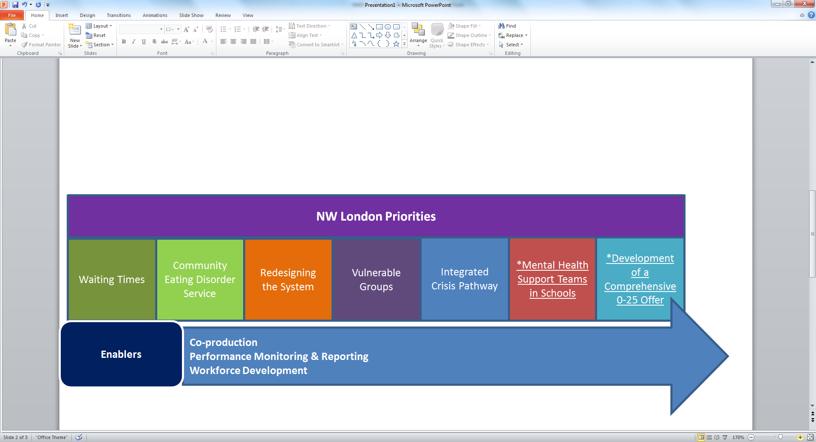

*Additional clinically-led transformation delivery areas for 2019/20 onwards, in line with NHS Long Term Plan.

Financing our Transformation Plans

Funding has been provided to CCGs by NHS England since 2016 to improve pathways and to support transformation of services to positively impact on CYP mental health. The majority of this funding have been invested with the two mental health trusts operating across NW London, with the remainder of the investment used to commission local voluntary sector services for CYP. Over this time we have also secured small non-recurrent funds to invest workforce development across NW London. The attached local annexes set out funding allocation across priority areas in each year. From 2019/20 onwards, baseline funding for CCGs is increasing in line with the commitemnts set out in the NHS Long Term Plan, and transformation funding associated with the delivery of specific initiatives has been secured.

Sustainability

The refreshed plan looks to strengthen the service developments already implemented and ensure prospective proposals will deliver better aligned and integrated pathways and interventions. Our whole-system approach will focus on making sustainable changes within pathways to deliver more cost effective care. We will review outcomes and value-for-money and make investment decisions based on meeting needs.

In 2019/20, we will be undertaking a NW London-wide review of patient flows, pathways, variation and population health attributes across the eight boroughs. This is being supported by transformation funding associated with the NHS Long Term Plan. This work will inform and support development and sustainability of our service transformation programme and commissioning strategy. This will help ensure that current and future mental health needs of our CYP are met and services are financially viable in the long term, at both borough and at scale across NW London.

Our approach to sustainability is built on:

* Working together with commissioners and providers to review effectiveness and value-for-money of services and outcomes delivered and agree areas to shift resources from old systems to fund redesigned pathways;
* Coordinating workforce planning across a larger footprint;
* Creating capacity through up-skilling in universal and early intervention services to support CYP in their communities;
* Identifying opportunities for more integrated placed-based care services linked to community and general practice;
* Identifying lower cost but effective interventions where clinically appropriate such as peer support, digital based access to information and support.

|  |
| --- |
| 5.1 Priority One: Access and Waiting Times |

**5.1.1 Our Ambition**

Our aim is to provide timely access to NHS funded mental health services for CYP, and to ensure that services are able to offer the full range of NICE recommended treatment options.

**5.1.2 Our Performance and Progress**

Increasing Access

The NHS Five Year Forward View target requires that at least 35% of children with a diagnosable mental health conditions are seen for treatment by 2020, or there is an increase in the numbers seen by at least 2% per year.

On average across NW London, we surpassed our 2018/19 plan (32%) for providing access to services – achieving an access rate of 34%.

However, there was considerable variation across the patch; four of our eight CCGs were below target last year. In part, this is because not all local providers are providing data to the Mental Health Services Data Set (MHSDS) the new national reporting mechanism.

Our commissioners and providers have commenced work to reduce issues with reporting with actions in place to ensure data is flowing to the national dataset across seven of our eight boroughs. Ealing CCG and Local Authority are getting support from the NHS Intensive Support Team to look at making improvements in how access data is collected in 2019/20 can be made.

The table below provides overview of access rates for each CCG.

|  |  |  |  |  |  |  |  |  |
| --- | --- | --- | --- | --- | --- | --- | --- | --- |
| **Progress towards target** | | **2016/17** | | **2017/18** | | **2018/19** | | **Target**  **2019/20** |
| **Target** | **Actual** | **Target** | **Actual** | **Target** | **Actual** |
| **CCG** | **Estimated prevalence** | 28% | **31%** | 30% | **31.3%** | 32% | **34%** | 34% |
| **Brent** | 4572 | 1280 | **1158** | 1372 | **1449** | 1463 | **1,180** | 1600 |
| **Ealing** | 4692 | 1314 | **1197** | 1408 | **1046** | 1501 | **1,030** | 1595 |
| **H&F** | 1828 | 512 | **867** | 548 | **850** | 585 | **1,450** | 622 |
| **Harrow** | 3171 | 888 | **940** | 951 | **1069** | 1015 | **910** | 1078 |
| **Hillingdon** | 4051 | 1134 | **1421** | 1215 | **575** | 1296 | **1,325** | 1377 |
| **Hounslow** | 3468 | 971 | **875** | 1040 | **1516** | 1110 | **980** | 1179 |
| **West London** | 1440 | 403 | **675** | 432 | **1189** | 461 | **1,080** | 489 |
| **Central London** | 2417 | 677 | **818** | 725 | **766** | 773 | **765** | 822 |

The above data represents both specialist CAMHS providers and the voluntary sector providers. The capture of data from smaller providers has been a particular issue, however, we are working collaboratively with all providers to ensure they are able to flow the required datasets into the MHSDS.

Referrals

The following table represents all referral activity.

|  |  |  |  |  |  |  |  |  |  |  |  |
| --- | --- | --- | --- | --- | --- | --- | --- | --- | --- | --- | --- |
|  | Central London | West London | H’don | Brent | Harrow | | H&F | Ealing | | H’slow | |
| Referrals made | | | | | | | | | | | |
| 2016/17 | 587 | 1096 | 1289 | 1657 | | 1079 | 1035 | | 2093 | | 1596 |
| 2017/18 | 702 | 1366 | 1302 | 1485 | | 1104 | 1403 | | 2350 | | 1683 |
| 2018/19 | 788 | 1183 | 1236 | 1469 | | 1220 | 1134 | | 2098 | | 1802 |
| Referrals accepted | | | | | | | | | | | |
| 2016/17 | 416 | 792 | 828 | 766 | 627 | | 922 | | 1638 | | 1108 |
| 2017/18 | 630 | 1112 | 982 | 1128 | 668 | | 1148 | | 1876 | | 1220 |
| 2018/19 | 655 | 1018 | 1047 | 1238 | 812 | | 783 | | 1374 | | 1448 |
| % Referral acceptance rate | | | | | | | | | | | |
| 2016/17 | 71% | 72% | 64% | 46% | 58% | | 89% | | 78% | | 69% |
| 2017/18 | 90% | 79% | 70% | 71% | 59% | | 82% | | 80% | | 72% |
| 2018/19 | 83% | 86% | 85% | 84% | 67% | | 69% | | 65% | | 80% |

Overall the number of referrals made in NW London has increased since 2016/17. However, the number of referrals made in made in 2018/19 decreased by 4% when compared to the previous year. The picture across the boroughs is varied with Central London (12%), Harrow (11%) and Hounslow (11%) making a significantly greater number of referrals than the in 2017/18.

The percentage of overall referrals accepted by CAMHS services across NW London increased by 18% from 2016/17. However, the number of referrals accepted in 2018/19 decreased by 4% when compared to the previous year, with Hammersmith & Fulham and Ealing reporting significant decreases in the number of referrals accepted (31% increase, 26% increase respectively)

Waiting Times

The continued focus and investment in 2018/19 to address waiting times across NW London has resulted in significant improvements: there were 27% fewer CYP waiting less than 4 weeks for an assessment and 19% fewer young people waiting more than 11 weeks compared to the previous year.

However, the number of CYP waiting greater than 5-11 weeks from assessment to treatment increased in 2018/19. This decline in performance is mainly due to significantly more CYP needing to wait longer than 11 weeks for their assessment in Hammersmith and Fulham, Ealing and Hounslow boroughs.

In 2019/20, we will be working with our providers and partners to complete a system wide review of how patients currently access our services (including waiting times) how this is expected to change, health inequalities and areas of good practice within NW London.

The exercise will complement the work that we are already doing with system partners in response the NHS Long Term Plan to collaboratively develop our future transformation programme through identifying the sustainable pathway and workforce changes required to continue to improve waiting times.

The data below shows waiting times for referral to assessment for each borough.

|  |  |  |  |  |  |  |  |  |  |
| --- | --- | --- | --- | --- | --- | --- | --- | --- | --- |
| [12]Waiting Times | | | | | | | | | |
|  | **Central London** | **West London** | **H’don** | **Brent** | **Harrow** | **H&F** | **Ealing** | **H’slow** | **Total NWL** |
| **Referral to Assessment Time** | | | | | | | | | |
| **Under 4 weeks** (total number of CYP) | | | | | | | | | |
| 2016/17 | 122 | 106 | 75 | 112 | 111 | 78 | 110 | 63 | **777** |
| 2017/18 | 167 | 141 | 127 | 82 | 103 | 142 | 132 | 53 | **947** |
| 2018/19 | 121 | 187 | 108 | 68 | 66 | 124 | 285 | 239 | **1198** |
| **5-11 weeks** (total number of CYP) | | | | | | | | | |
| 2016/17 | 57 | 147 | 34 | 124 | 151 | 127 | 46 | 111 | **301** |
| 2017/18 | 107 | 182 | 179 | 129 | 138 | 142 | 68 | 99 | **190** |
| 2018/19 | 103 | 107 | 106 | 38 | 81 | 209 | 86 | 91 | **196** |
| **Over 11 weeks** (total number of CYP) | | | | | | | | | |
| 2016/17 | 90 | 67 | 165 | 88 | 88 | 42 | 63 | 105 | **474** |
| 2017/18 | 28 | 40 | 198 | 72 | 72 | 8 | 108 | 101 | **369** |
| 2018/19 | 13 | 12 | 92 | 139 | 139 | 30 | 87 | 268 | **268** |
| **Assessment to Treatment** | | | | | | | | | |
| **Under 4 Weeks** (total number of CYP) | | | | | | | | | |
| 2016/17 | 122 | 99 | 104 | 181 | 133 | 112 | 121 | 83 | **955** |
| 2017/18 | 172 | 193 | 230 | 263 | 178 | 125 | 146 | 95 | **1402** |
| 2018/19 | 142 | 182 | 168 | 172 | 147 | 131 | 204 | 194 | **1340** |
| **5 - 11 weeks** (total number of CYP) | | | | | | | | | |
| 2016/17 | 35 | 50 | 24 | 80 | 64 | 46 | 20 | 72 | **391** |
| 2017/18 | 30 | 48 | 40 | 32 | 43 | 67 | 39 | 55 | **354** |
| 2018/19 | 31 | 45 | 31 | 11 | 20 | 95 | 53 | 66 | **352** |
| **over 11 weeks** (total number of CYP) | | | | | | | | | |
| 2016/17 | 16 | 30 | 34 | 35 | 38 | 26 | 18 | 50 | **247** |
| 2017/18 | 6 | 11 | 29 | 9 | 9 | 25 | 31 | 40 | **160** |
| 2018/19 | 3 | 7 | 9 | 9 | 4 | 51 | 63 | 181 | **327** |

**5.1.3 Next Steps**

There remains an on-going commitment to improving timely access to NHS funded mental health services, and to ensuring there are a range of evidence based interventions for CYP.

In the next phase of our work we will:

* Review access and waiting time data, use of resources and – working in conjunction with providers – establish any reasons for lower performance or variation in order to develop plans to address issues;
* Increase capability of the school workforce to provide help and support that will enable CYP to better manage their emotional and mental wellbeing with assistance from parents and peers. The role of CYP IAPT in doing this will be considered;
* Mobilisation of MHSTs in schools across our Wave 1 and Wave 2 pilot areas. MHSTs will be in place in Hounslow, West London, Hammersmith & Fulham by the end of 2019, mobilisation in Ealing to follow in January 2020;
* Review plans and commitment to develop single point of access across NW London to provide timely access to the right help, at the right time and place;
* Address data collection issues and work collaboratively with all providers to successfully feed access and waiting time data into Mental Health Services Dataset;
* Trial new ways of supporting access to services via digital means, where clinically appropriate and welcomed by CYP and families. This will be supported by investment for 2019/20 associated with the NHS Long Term Plan;
* Ensure that our mental health plans are aligned with those for CYP with physical health needs and vulnerable groups, to improve support for CYP.

|  |
| --- |
| 5.2 Priority Two: Community Eating Disorders (ED) Service |

**5.2.1 Our Ambition**

We want to provide rapid access to a wide range of evidence based care and treatment to CYP with eating disorders to improve outcomes and meet eating disorder access and waiting time standards.

**5.2.2 Our Progress and Performance**

CAMHS Community Eating Disorder Services were launched on 1st April 2016, following a year-long pilot service. Services are underpinned by the National Specification for Eating Disorder Services and are compliant with the NICE Guidance (CG9). The services are integrated into CAMHS in both trusts and are accessible Monday to Friday 9am to 5pm with additional support provided by the out of hours’ teams based in a number of EDs across NW London, and both Trusts. There is a wide ranging support available for CYP and their families, including:

* A rapid single point of low-threshold access;
* Advice, information and sign posting to people with eating problems who do not wish to access treatment services (or who are not eligible for treatment);
* Specialist consultancy to GPs whether or not the service is able to offer treatment;
* Seamless onward referral to treatment services for people whose needs cannot be met within a community-based service (e.g. those at higher risk or requiring multi-disciplinary treatment and care);
* Family interventions as a core component of evidence based treatment required for eating disorders in CYP;
* Cognitive behavioural therapy (CBT) and enhanced CBT (CBT-E) for the treatment of anorexia nervosa, bulimia nervosa and related adolescent presentations.

Both providers are registered with the Quality Network for Community Eating Disorder Services to improve their services, and have participated in self-assessments (below table) and peer reviews.

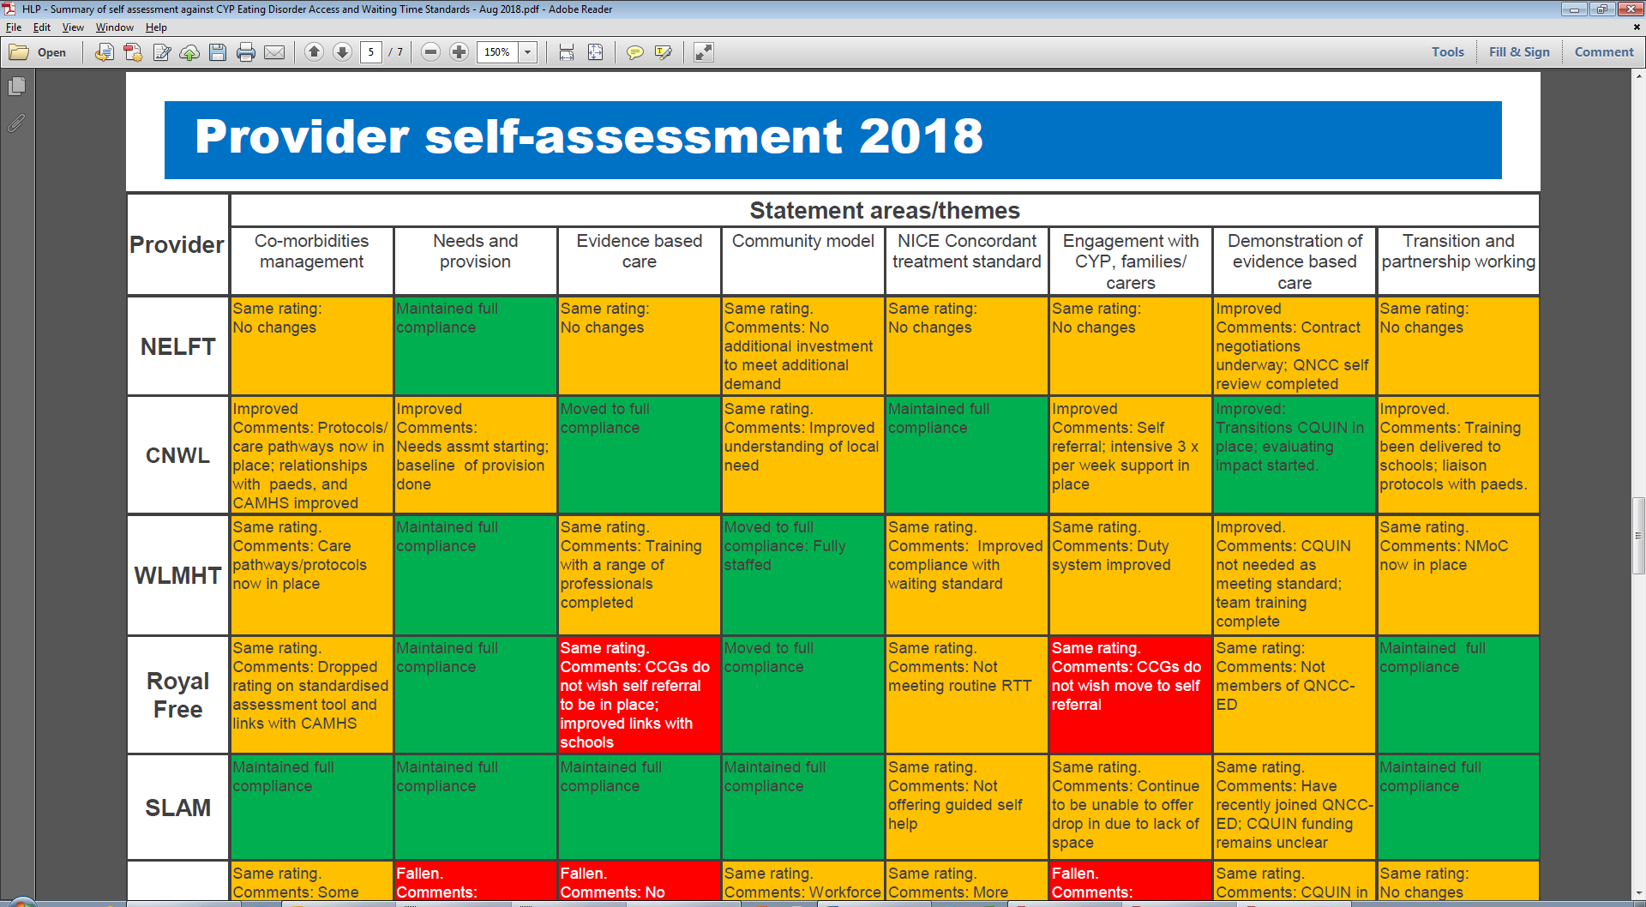

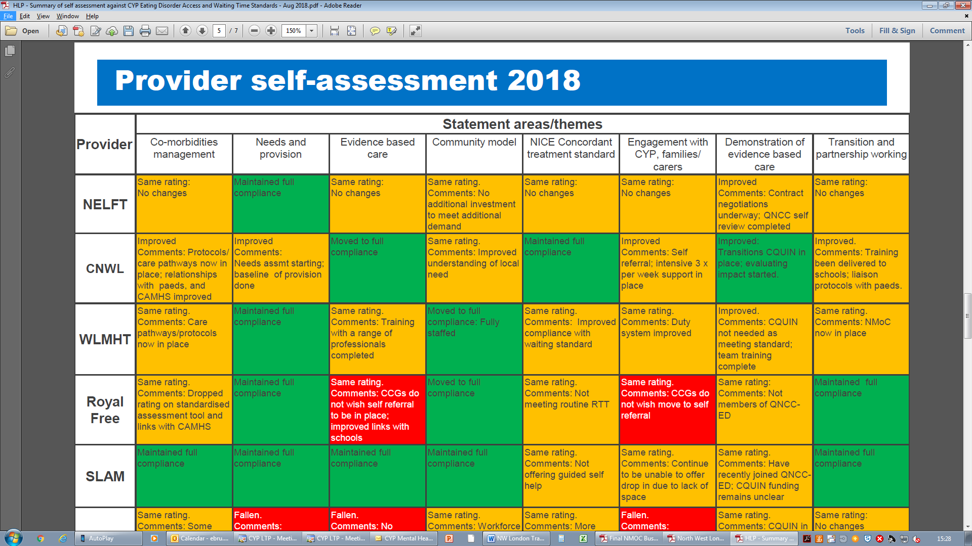

**Access and Waiting Times**

Referrals

The majority of referrals to eating disorder services since 2015 have come from GPs, followed by other CAMHS professionals, education professionals and social workers, with some young people self-referring to services.

In 2018/19 there were 169 routine (32% increase) and 21 urgent (70% decrease) referrals to eating disorder services in NW London, when compared to the previous year.

|  |  |  |  |  |  |  |  |  |  |
| --- | --- | --- | --- | --- | --- | --- | --- | --- | --- |
| **Referrals to Eating Disorder service by CCG** | | | | | | | | | |
|  | Central London | West London | H’don | Brent | Harrow | H&F | Ealing | H’slow | TOTAL NWL |
| Number of routine referrals (4-week) | | | | | | | | | |
| 2016/17 | 17 | 14 | 22 | 17 | 19 | 18 | 35 | 22 | 164 |
| 2017/18 | 28 | 28 | 50 | 38 | 38 | 23 | 48 | 37 | 252 |
| 2018/19 | 7 | 17 | 27 | 11 | 19 | 20 | 45 | 23 | 169 |
| Number of urgent referrals (1-week) | | | | | | | | | |
| 2016/17 | 6 | 6 | 6 | 6 | 5 | 1 | 6 | 4 | 40 |
| 2017/18 | 4 | 20 | 16 | 14 | 10 | 2 | 2 | 2 | 70 |
| 2018/19 | 4 | 5 | 1 | 4 | 5 | 1 | 0 | 1 | 21 |

Waiting Times

Waiting times for routine and urgent referrals are monitored by NHS England and NHS Improvement with targets of 95% of routine appointments to be seen within four weeks and 100% of urgent referrals seen within one week.

|  |  |  |  |  |  |  |  |  |  |  |  |
| --- | --- | --- | --- | --- | --- | --- | --- | --- | --- | --- | --- |
| Compliance to National Waiting Times (%) | | | | | | | | | | | |
|  | Central London | West London | H’don | Brent | Harrow | | H&F | | Ealing | | H’slow |
| % Compliance to routine (4-week) waiting times | | | | | | | | | | | |
| 2016/17 | 88% | 79% | 77% | 88% | 79% | 88% | | 89% | | 59% | |
| 2017/18 | 86% | 100% | 71% | 58% | 78% | 96% | | 92% | | 90% | |
| 2018/19 | 92% | 100% | 97% | 89% | 100% | 94% | | 92.5% | | 95% | |
| % Compliance to urgent (1-week) waiting times | | | | | | | | | | | |
| 2016/17 | 100% | 100% | 80% | 67% | 80% | 100% | | 83% | | 25% | |
| 2017/18 | 80% | 92% | 78% | 88% | 67% | 100% | | 100% | | 100% | |
| 2018/19 | 100% | 100% | 100% | 100% | 100% | 100% | | 100% | | 75% | |

All but one (Hounslow) of the NW London CCGs achieved the one-week wait time target (95%) for urgent referrals to CYP eating disorder services in 2018/19.

There has been a steady and sustained improvement in meeting the 95% CYP eating disorder four-week wait time target over the past year. At the end of 2018/19, five of our eight CCGs were meeting the target.

With minimal exceptions, breaches were attributed to families rearranging appointments, missed appointments, referral to alternative services and non-attendance rather than the ability to see CYP within the designated timescale.

Routine breaches are monitored at monthly meetings between commissioners and providers in each borough, with action plans implemented where performance does not meet agreed targets.

**Outcomes Monitoring**

As the services are now in their second year of operation, it has been possible to collect and compare baseline and end-of-treatment measures. Although the numbers are small, the outcomes look promising and show:

* Weight restoration to a healthy weight range in young people with anorexia nervosa;
* Significant reduction in eating disorder symptomology to below clinical thresholds;
* Reduction in anxiety and depression symptoms reported by young people and parents;
* Improvement in overall general functioning.

**Admissions**

Tier 4 admissions

In 2018/19 a total of 28 CYP were admitted into inpatient beds compared to 15 in the previous year, with further inpatient admissions avoided through providing support in the community preventing admission. However, the length of stay in 2018/19 (170 days) remained significantly below the 250 days reported in 2014/15 prior to services changes described in this document.

**Service Evaluation**

A second year evaluation of the service has been completed for both trusts to provide an updated position for 2018/19 in terms of access, activity/performance, outcomes, stakeholder satisfaction, safety and effectiveness given the current commissioned staffing model and service specification.

Improvements have been reported in the way both trusts operate in terms of establishing effective teams and the ability to start collecting and comparing baseline and end-of-treatment measures. Friends and Family Tests and survey feedback from CYP and their families have provided a positive outlook on their experiences. There are good processes in place: staff discuss incidents, share experiences in business meetings to support reflective practice and consider team functioning and dynamics.

A number of areas have been identified requiring further investment and redesign to improve capacity and effectiveness of the service, such as developing an intensive outreach to increase nursing provision for most high risk cases.

**5.2.3 Next Steps**

Good progress has been made in 2018/19 particularly in managing the needs in the community and prevention of admissions. There is further commitment to improve the services and our priorities in 2019/20 will be to:

* Develop case for change for implementing recommendations of the service evaluations and further improve waiting times performance and service effectiveness;
* Improve data collection, particularly in relation to recording goals and routine outcome data;
* Establish robust contract management/performance monitoring arrangements to regularly review compliance against national targets and standards, and mobilise improvement initiatives to address and issues or variation between services or boroughs;
* Ensure providers, specifically WLT, are compliant to The Quality Network for Community Eating Disorder services for CYP standards, and that recommendations emerging from self-assessment for eating disorder services are progressed within service areas.

**Feedback from some of our young people who have used the service (extract from the evaluation reports)**

“We were so lucky to find the psychologist who has been an angel for us. She has treated our case with deep interest and great tact. Session after session she gained the confidence of my daughter and made her be conscious of the tricks of the illness, giving her the skills to fight it. She listened to her carefully and treated her with sweetness.”

“I feel that the people who saw me listened to me”

“The team is exceptionally professional, caring and responsive. They always listen to our concerns and have given practical advice about handling several situations.”

**North West London Eating Disorder Service**

“They understood and knew how to help which made all the difference.”

“I feel the people here know how to help with the problem I came for.”

|  |
| --- |
| 5.3 Priority Three: Redesigning the System |

**5.3.1 The Ambition**

The single greatest cause of concern amongst our young people and the professionals they interact with is about the barriers between different parts of the system. This tiered care system has at times restricted and limited the ability of a child or young person being seen by the most appropriate person or service; at the most appropriate time or suitable place.

We have set our ambition to move away from tiered services and eliminate boundaries and challenges of the old system to a new system in which CYP are supported in their communities with services that are accessible and in accordance with the level of need.

**5.3.2 Our Progress**

We are working in collaboration with our partners to improve emotional health and wellbeing services across NW London where there is joint ownership of the issues and challenges we face, and a collective approach to finding solutions. Working in partnership helps us to have a much bigger impact on the lives of children and families than we would ever be able to achieve alone.

The commissioners, clinicians and other stakeholders engaged and involved in our transformation programme have agreed to adopt THRIVE[13] as a framework that supports our ambition to eliminate the boundaries between services and pathways and the culture shift needed across the system. The framework provides a dynamic and innovative approach, moving towards a goal-focussed model that is not defined by tiers, and places a greater emphasis on prevention and early intervention.

The THRIVE framework is a way of conceptualising need amongst a community of CYP and their families. Need is measured under the five categories.

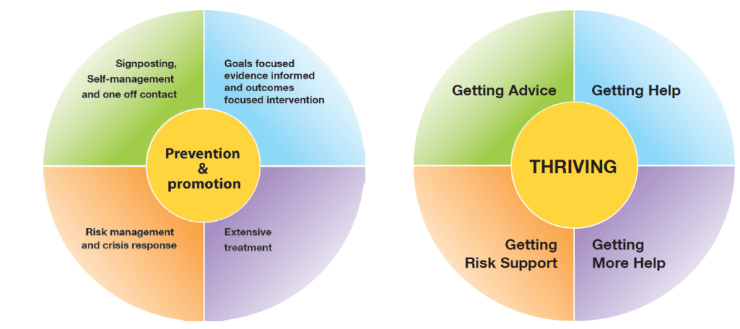***THRIVE conceptual Framework***

* **Thriving**: Focus on community based initiatives concentrating on prevention and promotion of emotional wellbeing.
* **Getting Advice**: Building resilience to support communities (school and family) to prevent, support and intervene in mental health issues.
* **Getting Help**: Focuses on health based interventions with clear treatment goals and set criteria to assess whether those aims had been achieved.
* **Getting More Help:** Emphasis on intensive and extensive longer-term health based treatment.
* **Risk Support:** Often resource intensive and requiring considerable input, this group focuses on those CYP for whom traditional health based care does not currently meet their needs.

Through adopting this framework, the outcomes we are seeking to achieve are:

* Reducing inequalities and improving health outcomes for CYP (including equality/social cohesion, financial inclusion, attainment levels);
* Building a sustainable future (environment and sustainability);
* Improving the quality of care and experience; and
* Improving value and efficiency.

In order to deliver our ambition and the above outcomes, numerous local initiatives have been implemented in boroughs to provide early intervention, expand access and improve the quality of the support and treatment offered. However in order to have a systematic approach to transformation and to minimise variation across boroughs, with the NW London areas of focus for improvement, which are set out in the below diagram.

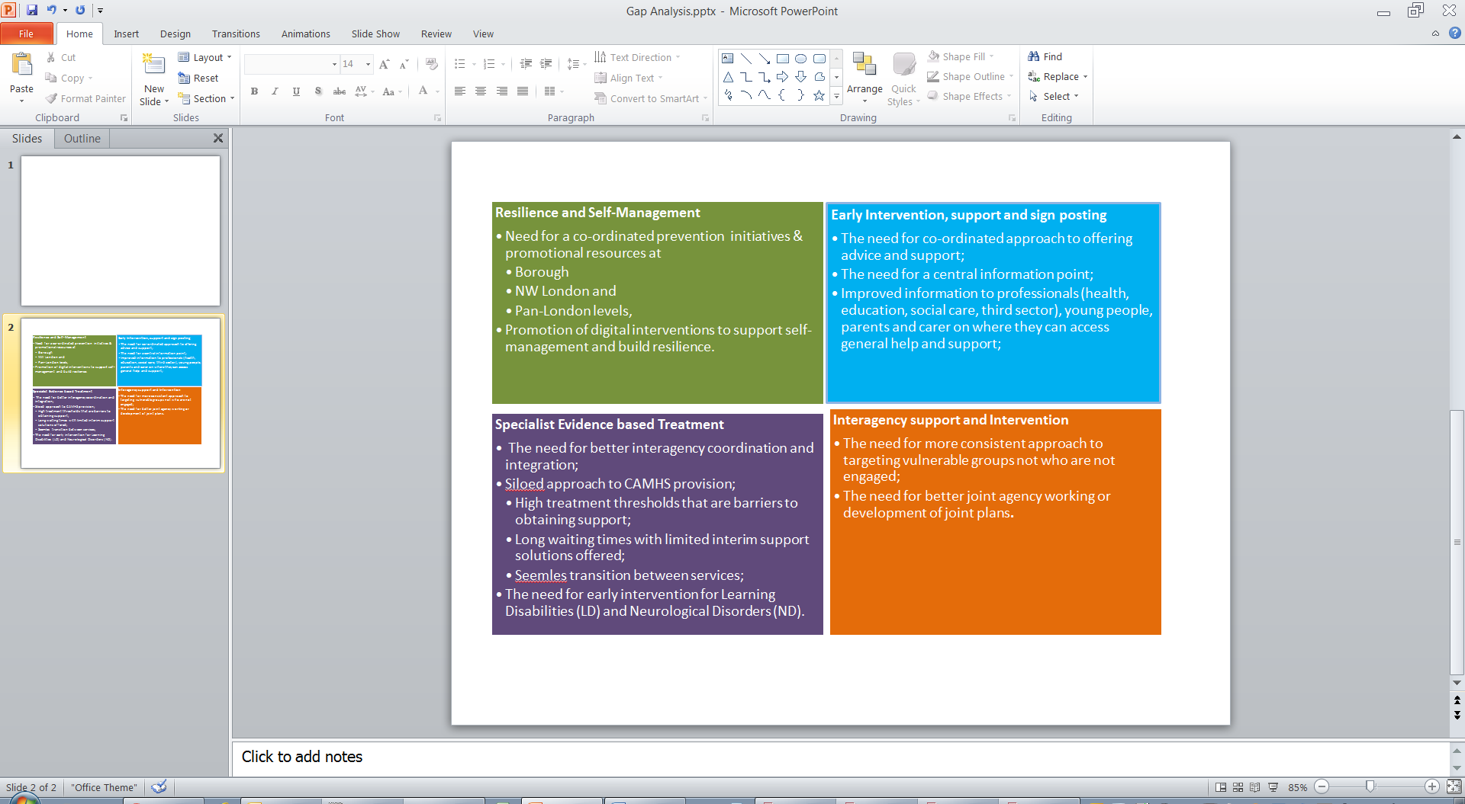

In line with the THRIVE framework, an overarching service model (diagram below) has been developed to be adopted in each borough to ensure a consistent offer across pathways and enable children to receive high quality support and care no matter where they live.

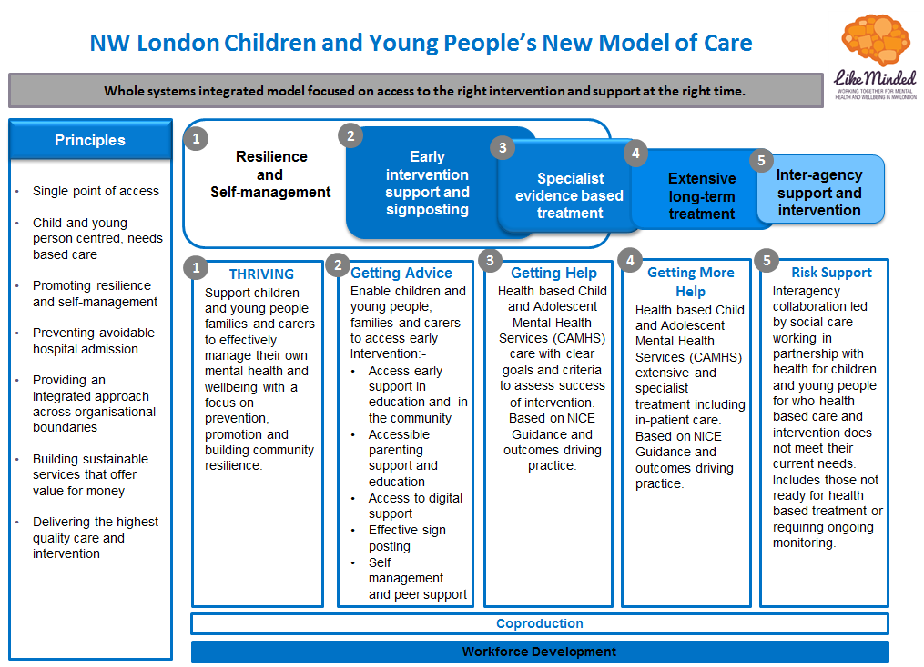

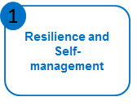**Step 1: Thriving** **–** this element of the model is underpinned by an asset based approach to build on existing community resources to develop prevention and promotion initiatives. It supports better recognition of CYP with mental health issues and facilitates implementation of local strategies which promote emotional wellbeing and resilience for the population.

There is a coordinated approach with key individuals identified and adequately trained to take a lead in promoting CYP mental health. Mental Health Needs Coordinators (MHeNCOs) are a key point of liaison and signposting to appropriate support and intervention. A centralised hub provides navigation to population based resources which promote emotional wellbeing.

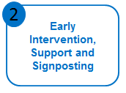

**Step 2: Getting Advice** **–** a focus on education, digital and community initiatives, getting advice seeks to enable CYP, their families and carers to easily access and navigate early intervention and support. Linked and coordinated Multiple Access Points (MAPs) across NW London facilitate easy access to help and support. Joint services are delivered by health, education and the third sector who proactively work in partnership and signpost individuals to the existing array of support that exists in each borough as well as to newly developed resources. This includes a digital offer.

There is a coordinated multi agency approach in place (local authority, health, third sector) to identifying the best treatment option, with intervention built around the needs, wishes and preferences of each child or young person. Support focuses on building individual, family and carer resilience.

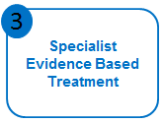**Step 3: Getting Help –** led primarily by health with third sector input, getting help provides access to specialist evidence based treatment programmes. Clear pathways provide easy access to specialist services for referrers and service users alike. There are minimal waiting times (within the national specification of 18 weeks). Following assessment, CYP have access to a range of treatment modalities and a care plan – built on shared decision making – is designed to reflect the needs, wishes and preferences of the child or young person. Goals are set which guide intervention and clear end points discussed at the start of treatment.

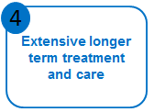

**Step 5: Getting More Help** – led by health, this aspect of the model supports CYP who require extensive and intensive treatment. Clear pathways provide intensive community outreach, inpatient care and early community discharge initiatives. Where possible, care will be delivered by highly skilled community teams who can provide treatment close to home. Care is coordinated across the system to ensure appropriate treatment can be accessed no matter where the child or young person accesses help.

**Step 6: R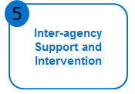isk Support –** inter-agency collaboration ensures access to appropriate support and intervention for complex children who are at risk or who pose a risk to others, but for whom services are not applicable. This includes those who refuse or don’t attend treatment, have not responded to treatment or routinely go into crisis. Social care is the lead agency. A flexible system provides easily accessible and adaptable support when required.

The key to delivery of our vision is a far greater emphasis (including investment) in prevention and earlier intervention across the system. However, as we move forward with implementation planning, the challenges of delivering ‘early intervention, support and signposting’ across eight boroughs, involving eight clinical commissioning groups, eight local authorities, two mental health trusts and 743 educational establishments has become clearer. Through engagement and conversation with key stakeholders, CYP, education colleagues, local authorities and voluntary sector, it has been agreed that early intervention and prevention works best when delivered at borough level where local relationships can be built and community needs met.

Across NW London CCGs are working collaboratively with their local partners to increase their early intervention and prevention offer for CYP mental health, and have utilised part investment to enable a co-designed programme to be established with voluntary sector and local authority providers of CYP services. Further information can be found in each annexe setting out how boroughs are implementing local programmes to meet their ambition.

The delivery of the remaining components of the THRIVE Framework and our new service model is progressing across NW London footprint. This collaborative approach has enabled the sharing and implementation of good practice, development of consistent pathways and quality standards, leading to improved quality and towards equitable services across NW London.

* + 1. **Our Next Steps**
* Undertake a THRIVE self-assessment of the system to determine how ‘THRIVE-like’ we are and what actions are required to improve and embed the use of THRIVE principles in all areas of work;
* Review our collaborative plans and projects to look at delivering more efficient use of resources by commissioning and delivering some services at scale;
* pathways in line with the NHS Long Term Plan as we work through whole system CAMHS transformation. This will include improving CAMHS element of Education and Care Plans. Our intention is also to ensure that this work aligns to existing best practice in Early Intervention Psychosis;
* Establish relationships, using emerging networks and transformation frameworks, for better integration of pathways with paediatric services to champion mental health needs of CYP with physical health issues.

|  |
| --- |
| 5.4 Priority Four: Vulnerable Groups |

**5.4.1 The Ambition**

In the last two years, we have changed our focus on the scope of vulnerable groups as it was previously limited to CYP with a learning disability (LD) and autistic spectrum disorder (ASD). We have widened the scope of this priority area to include other vulnerable groups such as those;

* With LD and/or ASD and challenging behaviour;
* Who are in the transition process;
* With conduct disorders;
* Who are involved in the youth justice system;
* Who are looked after children.

The NW London ambition is to ensure emotional and wellbeing support is available and easily accessible for our most vulnerable CYP, and that they are supported to achieve good outcomes through specialist help and skilled workforce.

**5.4.2 Our Progress**

**5.4.2.1 Children and Young People with Learning Disabilities and Neuro-developmental Disorders**

In NW London, diagnosis and support services for CYP are commissioned at borough level. A recent mapping exercise has highlighted gaps in provision, including NICE recommendations for waiting times for assessments. The national Transforming Care Programme officially ended in March 2019. This programme of work has now become part of the wider commitments in the NHS Long Term Plan for people with LD and/or ASD to reduce health inequalities and support all people with LD, autism or both to live longer, happier and healthier lives.

A review of local work programmes has taken place to determine the optimum delivery and governance arrangements to ensure that ‘Building the Right Support’ and the NHS Long Term Plan can be implemented effectively. The NW London Transforming Care Board has been replaced by the LD and Autism Steering Group which will cover the needs of CYP and adults. This approach will help ensure a consistent approach across the age range and improve transitions in to adulthood. There will remain an interface with the wider CYP mental health programme of work, ensuring that the needs of CYP with LD and/or ASD can be met within mainstream provision (e.g. crisis care, eating disorder services) via reasonable adjustments where appropriate and safe.

There are new national targets for inpatients. For CYP aged under 18 with a learning disability, autism or both, we are aiming for no more than seven young people to be cared for in an inpatient facility (consistent with national targets of between 12 and 15 per million of our population) by 2023/24. We need to change the way we work across the system to ensure we can adequately support CYP in the community. In line with NHS Long Term Plan investment over the coming years, we will improve the capacity of intensive, crisis and forensic community support services for CYP. In 2019/20 work will focus on mapping and assessing current community provision. Over the next three years, autism diagnosis will be included alongside work with CYP mental health services to test and implement the most effective ways to reduce waiting times for specialist services. NHS England and Improvement is overseeing implementation of the LD and autism programme and monthly assurance process are in place in relation to the agreed actions of the workstream.

**Performance**

Implementation of the Transforming Care Programme in NW London during 2018/19 has seen a reduction in the number of CYP cared for in an inpatient setting. There were eight patients on 31 March 2019 as compared to 12 the previous year. Collaborative patient surgeries have improved our understanding of the needs, challenges, and gaps in services, and helped to avoid unnecessary admissions and delays to discharges. We produced guidance to standardise and implement dynamic support registers and multi-agency Care Education Treatment Reviews (CETRs) across the footprint to minimise admission and length of stay. Dynamic support registers are now routinely being used in most CCGs to support CYP with learning disabilities and / or autism who are in, or approaching crisis. Where these are not already embedded in business as usual operations, there are plans in place to mobilise. We need to continue to work closely with local teams in the community to be proactive in developing and reviewing their dynamic support registers and work with local commissioners to plan community CETRs. Partners continue to work closely together to ensure that the commissioning of community services responds to individual needs of CYP to enable their safe and appropriate discharge, with a robust package of care in the community.

An analysis is underway to fully understand the factors leading to admissions at the beginning of 2019. Seven out of the eight CYP patients in hospital as at 31 March had a diagnosis of autism only. Young people who receive an autism diagnosis whilst they are in hospital continue to be added to our register. These patients tend to be in mainstream schools and not in receipt of services from social care, and would not have met the criteria for inclusion on the dynamic support register or a community CETR. This signals the need for early diagnosis and intervention. A service operating/delivery model which aligns with the CAMHS service model / THRIVE framework has been adopted for CYP. During the forthcoming year, we will review this model to take into account the ambitions in the Long Term Plan.

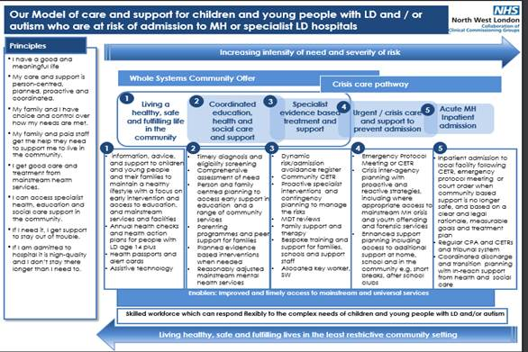

***Steps 1 – 2*** of the model rely on a whole systems community offer which includes improved and timely access to mainstream and universal services as well as timely diagnosis, early intervention and specialist evidence based treatment and support provided by the local teams when needed. The starting point will always be for mainstream services to support CYP with LD and/or ASD, making reasonable adjustments where necessary and with access to specialist multi-disciplinary support from health and social care teams as appropriate to ensure this cohort experience the same health outcomes in line with the general population. For these young people, access to annual health checks (for those aged over 14), health action plans, health passports and / or alert cards are particularly important. LD and autism awareness training should be available for professionals working in universal services

Also, key to the success of the model is person/family centred support planning with access to skilled and experienced staff in schools and community settings e.g. youth clubs, after school clubs. Technology based support which contributes to increased independence will be considered as an addition or alternative to traditional support models.

The model recognises the importance of good support to families, ensuring they have access to support well before they reach crisis point. Parenting programmes, advocacy, information, advice and training will be available for families to support them in their parenting role, including access to peer support.

***Step 3*** of the model describes the additional specialist clinical and social care support that should be made available to CYP with complex sensory, emotional, behavioural and/or mental health needs who are presenting some level of risk to themselves or others which can’t be safely managed by universal services or within their current care package. Interventions will be dependent on individual need but could include functional behaviour assessments, positive behaviour support plans, communications passports, medication reviews, restriction reduction plans, offender programmes and sensory integration plans. Clinicians will provide specialist training and consultancy to community and education providers and families to support them to create capable environments at home and in other community settings. Family therapy will be made available, especially during any transition phases. Access to reasonably adjusted offender programmes and interagency treatment and support will be made available to CYP with offending behaviour.

Dynamic risk/admission avoidance registers will be used systematically to identify CYP who may be at risk of admission, exclusion from school or placement breakdown with regular MDT discussions with local commissioners to formulate contingency plans and specialist early interventions. There will be a link between the children and adult registers, where young people are approaching transition. Where it is felt that the risks are likely to continue to escalate, a Community CETR should be organised.

***Steps 4 – 5*** illustrate the interagency interventions needed to support CYP in crisis and avoid exclusion from school, unnecessary admissions to inpatient units or 52-week education placements. This includes the need for crisis and contingency planning via emergency protocol meetings where there is insufficient time to organise a community CETR. Crisis and contingency plans and health passports will be shared with relevant clinicians working in mainstream MH crisis services including A&E. A social worker or key worker will be allocated to lead on support planning which will consider the impact on the family system and make provision for short breaks and additional support.

Crisis and relapse prevention treatment and therapeutic offending programmes led by a specialist forensic team will be available for CYP with serious offending behaviour who are at risk of admission to hospital or contact with the criminal justice system.

If CYP are admitted to hospital, it will be following a CETR, emergency protocol meeting or court order and be in a service close to home. Where safe and appropriate, patients with autism or mild LD and a mental health diagnosis should be able to access mainstream CAMHS beds, with in-reach advice and support from the specialist team if needed. Clinicians and social workers within the relevant community teams will work with commissioners to agree the outcomes of the admission which will be made explicit in the contract with the inpatient provider as well as the patient’s care and treatment plan.

Following an admission, especially those without a community CETR, the relevant team(s) in consultation with the commissioner should undertake a root cause analysis to identify any unmet needs, share lessons learned and reflect on what, if anything could have been done differently to avoid the admission. The findings will then be used to inform changes to local policies and practice.

**Local Initiatives/Pilots**

Much of the Learning Disabilities and Autism Programme is driven locally due to the essential part played by the local authorities and education. Some examples of local pilots and initiatives which aim to support early identification and/or targeted interventions for children and young people and their families in the community are highlighted below:

* **Ealing Council** have used funding from the Department of Education to develop their *Building My Future* project to provide youth work, advocacy, mentoring and family therapy, to young people with learning disabilities and/or autism aged 11 plus on the edge of care within the mainstream school structure. The project sets out to ensure that young people and their families receive wrap around support at an earlier stage to reduce the risk of crisis, family breakdown, exclusion and admission, and to support successful transition to adulthood. A Risk of Escalation Tool which will be developed to identify those who meet the criteria for the programme has the potential to be shared nationally as a best practice model.
* A **Hillingdon** parent has established a parent to parent initiative and set up a group offering peer support and support for positive emotional well-being and emotional regulation for parents of children with ASD/ADHD.  Feedback from group members is positive and the CCG will be working with the group to evaluate the outcomes and benefits of the group in 2019/20.
* **Hounslow** have developed an intensive community support service for CYP with autism and/or LD who display challenging behaviour and are subsequently at risk of admission, exclusion or placement breakdown. The model is a collaborative initiative between clinical psychology, social care and short breaks services. Families are provided with an individually tailored package of short-term intensive psychological interventions and additional short breaks, using a Positive Behaviour Support (PBS) and Systemic approach.
* We are using funding from NHS England to create family assertive outreach workers to focus support to vulnerable families of autistic children and young people living in Ealing and Hounslow. This initiative aims to develop the families’ capacity and infrastructure, and support their relationship and engagement with services. This approach will be reviewed and findings will be used to support wider roll-out across NW London.

**Collaborative Commissioning and Tier 4 Beds**

Specialised Commissioning are working with CNWL and Elysium to develop London based specialist Tier 4 inpatient CAMHS to deliver better access to care for children and young people with LD and/or ASD closer to home.

* 5-bedded specialist Tier 4 inpatient CAMHS LD unit to be provided by CNWL at the Kingswood site in Brent, from early 2019. This will offer a mixed gender service for young people aged 14 – 18 with LD and challenging needs and /or mental health condition,
* 9-bedded specialist Tier 4 inpatient CAMHS neuro-developmental disorders unit provided by Elysium. The service is based in Potters Bar and will be available to young people aged between 13 – 18 who have an already established diagnosis of ASD, with or without LD.

The development of London based services provides an excellent opportunity for partnership working between the TCP, NHSE and the providers to integrate provision within the wider local care pathways and support early engagement of families, local clinicians, social workers, and community providers in discharge planning. As with the national New Models of Care programme, this initiative is likely to lead to a reduction in spend on inpatient provision. We are keen to work with NHSE to explore the potential of re-investing any savings into developing the community infrastructure and services which offer children and young people an alternative to a hospital admission.

**Next Steps**

* Finalise the dynamic support register of those children and young people who may be at risk of an inpatient admission and embed the CTR/CETR processes locally for pre-admission and discharge meetings involving all partners and users/carers to design and commission individualised packages of care and support,
* Undertake a deep dive into Community CETRs and children and young people admissions to identify good practice, gaps in local services and processes and what can be done differently to avoid unnecessary admissions in the future,
* Building on the processes already in place for adult patients, consider introducing a systematic approach for escalating delayed discharges and CETRs, to unblock barriers,
* Deliver clear joined up approach: linking services so care pathways are easier to navigate for all children and young people, including those who are most vulnerable,
* Develop collaborative commissioning plans with NHS England Specialist Commissioning for children and young people with complex needs and develop a robust crisis and community based response to crisis offer,
* Identify external funding opportunities to establish alternatives to admission,
* Review and share findings of local initiatives such as positive behaviour support, family assertive outreach workers and the use of digital technology for rolling out across NW London footprint,
* Improve access for families to pre and post diagnostic support and neuro-developmental assessments and support, including consideration of footprint wide service specification to reduce variation of care across boroughs,
* Investigate adoption of Health Passports to support mainstream primary and secondary healthcare services to improve access to care and treatment for young autistic patients,
* Review neuro-developmental pathways in order to reduce waiting times and embed the transforming care principles to reduce the use of residential placements,
* Embed sustainable PBS training across NW London,
* Complete ‘borough level self-assessment’ against TCP model and principles, and to identify gaps to form the basis of the local and NW London level action plan.

**5.4.2.2 Transitions**

The period of transition from children’s to adult mental health services (AMHS) can be a very challenging time for young people and their families. In recognition of this, NW London is committed to improving the experiences of everyone involved in the process to ensure smooth transitions to adult services, as well as improving the support and journey of those who are leaving CAMHS at 18.

As part of this commitment, NW London commissioned Young Minds to develop a train the trainer intervention for CAMHS, AMHS and education which focussed on improving the support and journey of young people leaving CAMHS. Between May and August 2018 Young Minds worked with young people, carers and professionals to understand their experiences of transitioning from CYP to adult mental health services, map pathways, identify gaps and complete an audit around development needs.

One hundred and forty-seven people participated across the eight boroughs (73 young people, 35 parents/carers, and 39 professionals). They identified a number of key challenges in the relationship between child and adult services which were deemed more critical in improving the experiences of young people, families and professionals, including:

* Between child and adult services, there is a lack of understanding about how the other service works and a lack of shared understanding about the needs of the young adults aged 18-25;
* There is often poor communication between services. Our stakeholders would like to see dedicated leads for transitions in CAMHS and AMHS accountable for ensuring the transition protocols are implemented in both services, regular meetings between services, and buddying up;
* Lack of suitable environment for young people moving into adult units;
* Lack of suitable options for young people who still need support at 18 but cannot access on-going support due to thresholds;
* More accessible resources for parents and carers about what happens when young people approach 16/18 and about their rights;
* More information for parents whose child is moving to adult services around how it is different and what to expect; and
* Whilst the concept of a specific service provision/team has come up a number of times, challenges of a ‘transition service’ were also recognised by some families and professionals; with concerns that this would create another age-related divide between services.

The project has resulted in commissioners and providers gaining a rich picture of current challenges and strengths around transitions and generated new ideas about how transitions could be improved. Based on the findings of this phase we agreed to augment the insight phase to undertake further engagement with hard to reach groups, a larger cohort of education providers and general practitioners to get a more holistic picture of the current system.

Young Minds are continuing to work in phase three of the project to: facilitate culture change by organising ‘communities of practice’; develop principles and resources to be adopted across the system; and build relations across children’s and adult’s services. Processes and protocols will be informed by the learning gained from the action learning sets and the local development of initiatives.

Progress continues with the transitions out of CAMHS CQUIN. During Q4 of 2017/18, a case note audit took place for individuals transitioning to adult mental health services during Q4. The work evidenced that 74% of those audited were transferred back to primary care and 26% met the thresholds for AMHS. Additionally, both CAMHS and AMHS conducted surveys to understand the experience of those transitioning from CAMHS.

A further survey in Q4 2018/19 was offered across London. The CNWL CAMHS services participated in the audit which showed that 71.8% of cases were transitioned back to primary care, with 69.8% undergoing Joint Transition Planning when transitioning into adult services or back to primary care.

**Next steps**

* Continued Young Minds work to finalise service user and clinical engagement through ‘communities of practice’ and develop training resources for use in NW London.
* Complete modelling of ‘as-is’ position and future requirements to develop key deliverables identified in the final report e.g. gap analysis for service provision, training programmes, action learning sets, principles and resources including enhanced NHS passport for commissioners to approve, to inform our planning for 2020/21 onwards.
* Begin initial work locally to understand next steps around the NHS Long Term Plan ambition to create a comprehensive 0-25s model.
* Continue monitoring CQUIN achievements to improve performance and determine what extra measures are required, including review of the current survey methodology and rolling out good practice process currently in place in some of the boroughs.

**5.4.2.3 Complex Needs – Early Intervention in Psychosis**

It is important to provide support to CYP with a first episode of psychosis as early as possible. Early intervention and treatment can improve long-term outcomes. NW London performance for the proportion people experiencing a first episode of psychosis treated with a NICE package within two weeks is significantly above the set target.

**Next Steps**

* Develop a robust monitoring framework to monitor the performance of services, including understanding of skills gaps, training requirements and workforce vacancies.
* Review the effectiveness of the service model, including the NICE compliant interventions, to identify gaps and service improvements whilst reducing demand on core CAMHS services.
* Develop robust local arrangements between CAMHS and EIP services so that specialist expertise in working with CYP with psychosis is available.

**5.4.2.4 Young People in the Criminal Justice System**

*Future in Mind* outlined the need to transform ‘care for the most vulnerable’ which includes the mental health of children who are in contact with the criminal justice system.

NW London has prioritised supporting CYP in or at risk of entering the justice system and utilised additional funding to provide timely assessment and diversion through mental health liaison and diversion support, and introduced targeted interventions through community approaches which have promoted social connectivity and community resilience. Liaison and diversion support is commissioned and funded through NHS England and the Youth Justice Board and discussions will need to take place to agree arrangements for funding beyond March 2020.

As part of the support offer to CYP who have entered the justice system Harrow CCG have jointly funded a dedicated CAMHS worker with the local authority. This post offers a forensic lens to the youth offending team and enables assessment and support to be offered in the community as well as in custody.

In an effort to support CYP who have entered the justice system, Hounslow have funded a dedicated CAMHS nurse who forms part of their youth offending service. This post helps to provide advice and training for the workforce, mental health assessments for young people where a need is indicated at initial screening, and focussed interventions as required. Going forward, Hounslow have plans to develop the mental health offer for those CYP on the edge of the justice system, in an effort to strengthen the preventative offer and reduce the number of first time entrants to the justice system.

Further information and examples on local progress can be found in local annexes: each borough has progressed their individual plans given the multi-disciplinary and multi-agency approaches within the pathways.

**5.4.2.5 Looked After Children**

LAC frequently have multiple and complex needs. To address these needs a multi-agency approach with education, health and local authorities working in partnership is essential. There are plans in place in each NW London borough, working in conjunction with local authorities, education and voluntary sector to meet the needs of LAC. Further details can be seen in local annexes.

**5.4.2.6 Conduct Disorder**

A pilot, ‘Expanding Parenting Provision’ was set up in Ealing to test an integrated approach between health and education to prevent and/or intervene in the development of conduct disorder through early identification, training and positive parenting support delivered within schools. The pilot was delivered in two phases; the first phase taking place between September and December 2017 in which participating schools, staff and supervisors were identified and trained to deliver the pilot. In the second phase taking place between January and July 2018 parents were trained. The pilot has so far delivered 14 parenting courses in seven Ealing schools by end 2018. 117 parents participated in the courses, with 80 attending the tenth and final session. Evaluation has demonstrated a significant improvement in parent-reported child behaviour (50% improvement in 'Concerns about my child' score; p<0.00001), and a significant improvement in parental well-being (3 point improvement, Short-Warwick-Edinburgh mental wellbeing scale 'SWEMWBS'; p<0.00001), for parents completing the course. Evidence suggests there have been improvements in classroom behaviour, although this was for a small sample of children (n=37) using a non-validated measure. Parents also reported improved community connectedness as a result of these group courses.

Uptake from schools was favourable, and the programme has provided opportunities for professional development for staff. There were family identification/recruitment challenges for some schools, and targeting of higher-need families was universally challenging. Only one third of participants' children had behavioural issues identified, meaning the pilot was operating more as a universal prevention programme.

A challenge to resourcing of this pilot was the operative demands of multidisciplinary and integrated working, for example between multiple clinicians and multiple schools. In order to scale up it will be necessary to find ways of streamlining these processes. Plans are underway in Ealing to sustain the pilot through training parents from these courses to deliver further sessions in the community especially as an offer to parents of CYP who are on waiting lists for CAMHS. The full evaluation will be completed in 2019/20 and will be used to inform plans for wider implementation of the model across NW London.

|  |
| --- |
| 5.5 Priority Five: Integrated Crisis and Urgent Care Pathway |

**5.5.1 The Ambition**

The Five Year Forward View requires the NHS to deliver effective 24/7 crisis resolution and home treatment services to ensure community based mental health crisis response is available in all areas. This includes adequate resourcing to offer intensive home treatment as an alternative to acute admission.

In NW London our aim is to develop an equivalent model for CYP and we want to provide integrated 24/7 support and intervention for CYP in mental health crisis providing timely access to care and support, reducing avoidable or inappropriate admission to hospital, , and linking them to intensive community support services.

**5.5.2 Progress**

**Integrated Crisis and Urgent Care Pathway**

The early stage of the transformation programme has seen the piloting and commissioning of the ‘Out of Hours Crisis Services’ by two Trusts. This covers all boroughs to provide support to CYP with higher levels of mental health need, bringing parity of esteem for those presenting in emergency departments (EDs) during out of hours. Assessment services – provided by qualified CAMHS nurses – have been available to all CYP who present in crisis in EDs, Urgent Care Centres, and Section 136 suites, and when an emergency admission is sought.

The evaluation of the services was undertaken at the end of the pilot phase and although they had met the general aims, the following challenges were identified;

* Difficulty recruiting staff on this shift pattern leading to over reliance on agency staff;
* Challenges with capacity due to delivering services over a large geographical area leading to reliance on existing staff such as Psychiatric Liaison Services to review CYP within contracted timescales;
* Fragmented service provision with out of hours not linked to in-hours crisis services;
* Health focussed with limited social care input;
* Capacity to support training of ED staff limited in some areas;
* Due to capacity, limited ability to fully support other colleagues i.e. police, paramedics; and
* Intensive community service focussed on reducing unnecessary admission not in place in all areas.

In order to address these challenges, additional funding was identified and allocated in April 2017 to pilot two-year fully integrated 24/7 crisis and urgent care and community based outreach teams ensuring all CYP experience the same high-quality care and consistent pathways..

The integrated 24/7 service was launched to provide intensive crisis and community intervention to prevent unnecessary hospital admission, facilitate early and safe discharge, reduce prevention of admission, reduction in length of stay and a reduction of admission to acute paediatric beds across the NW London footprint. The teams are offering ED liaison assessments, seven day follow up, supported discharge and home treatment. This new service has also been an enabler for the NMoC project in facilitating discharges from out of area placements. The vast majority of cases assessed were for self-harm, suicidal ideation and overdose incidents, and the promotion of the service across the system has been instrumental in identifying young people early to provide timely support. NW London acute hospitals have CAMHS liaison in place and robust links between CAMHS and adult liaison psychiatry are already established.

To further support the development the crisis pathway, additional funding of £192,000 was also secured from the national crisis funds to develop an enhanced training programme to enable crisis teams to manage more complex patients in the community, including CYP with learning disabilities and autism spectrum disorder. The funding has been used to train all urgent care staff in specific modalities for crisis, and delivered the following benefits:

* Interventions from initial assessment in ED with safe discharge back in to the community to facilitate earlier discharge from Tier 4 beds and prevent Tier 4 admissions;
* On-going shadowing of other professionals across the health and social care system to foster good working relationships; and
* Facilitating on-going reflective practice and supervision slots to ensure robust systems are in place to promote best practice for patients and psychological safety/wellbeing of staff.

**CAMHS Tier 4 Beds**

During 2018/19, the total number of admissions to Tier 4 beds in NW London was 261, of which 68 were due to re-admission, transfers of care or repatriations. The total number of individual CYP (193) admitted was greater than the recorded admissions in the previous year of 158 CYP.

There were continued improvements in numbers of occupied beds days for children placed outside of their local area, and the average length of stay in service reducing to 90 days. These improvements have resulted in less disruption to family life, education and young person’s social life and minimising adoption of risky behaviours from peers.

Out of Area - occupied bed days

## Collaborative Commissioning – New Models of Care

In October 2016, a collaboration between WLT and CNWL, NHS England Specialised Commissioning launched the NMoC pilot project to address concerns related to the provision of CAMHS Tier 4 beds including capacity issues, problems accessing required beds and CYP travelling long distances to access inpatient care. The purpose of the pilot was to trial new ways of managing the pathway to Tier 4 inpatient admissions to:

* Prevent avoidable psychiatric hospital admissions;
* Admit young people closer to home when needed;
* Reduce length of stay for young people admitted to Tier 4 beds;
* Eliminate clinically inappropriate out of area placements; and
* Reinvest savings in improved community services for young people.

Following a 12-month shadow period, the pilot project was mobilised under a two-year contract in April 2017 as a partnership between WLT (as lead provider), CNWL, the Priory Group, and the eight CCGs within NW London. During the first year of the pilot the NMoC project successfully delivered:

* Efficiencies and savings against the Tier 4 budget;
* Reduced hospital admissions;
* Reduced length of stay;
* Established new ways of working and new pathways between the community Tier 3 services and Tier 4 services;
* Improved the provision of care closer to home through reduced out of area placements; and
* Improved clinical outcomes for CYP.

Across the two years, the CAMHS NMoC has achieved approximately £3.8m in savings; reinvested into frontline CAMHS provision to support the crisis pathway for NW London. This has focused on improved provision of day-time crisis response at point of presentation, admission avoidance by managing the crisis at home and increasing step-down care from the Tier 4 inpatient provision for young people.

As per the NHS Long Term Plan, there is an ambition to move specialist care to NHS-led Provider Collaboratives from April 2020. The NW London CAMHS NMoC has been designated fast track status: it will move from being a pilot to becoming business as usual from April 2020. In addition to the scope of the original NMoC work, the Collaborative will also take on the provision of inpatient care for CYP with learning disabilities and/or autism.

## Collaborative Commissioning: Lavender Walk Provision of Tier 4 Beds

In 2018, CNWL was given confirmation to build and develop a new inpatient unit in South Kensington for adolescents with mental health difficulties. The development of 12 beds was deemed critical as there was a concern about a shortage of dedicated adolescent beds in NW London, which was hampering the effectiveness of community crisis pathways. Whilst the needs of children are managed in their communities and at home, there are times short hospital stay is needed and the new unit: provides the capacity and flexibility to improve treatments for young people closer to home; better ability to manage bed availability; facilitates reduced length of inpatient stay by keeping care local; and provides more support for families and reduces disruption to a young person’s life. The new unit became operational in November 2018 and the model of consists of two components:

1. Clinical Model

The Clinical Model is aligned to the principles of the NMoC project. It moves away from the traditional approach that aims for full clinical recovery in hospital, leading to long lengths of stay. Instead, the focus of admissions is on initiation of treatment and community risk reduction interventions to support early discharge and ongoing treatment at home. Critical to the model is highly integrated inpatient, crisis, and CAMHS care pathways; and a flexible, needs-led approach to care planning and delivery.

The unit provides a crisis and brief admission service for young people aged between 13 and 18 years with severe and/or complex mental health conditions associated with high medical or psychosocial risk. Length of stay will vary according to individual need, with the majority falling between 1–28 days. Discharge planning commences on day of admission, using a partnership approach between inpatient services, community crisis teams, family and other community services such as schools.

1. Day Patient Model

This is an integrated community treatment programme with the capacity to offer intensive multidisciplinary treatment for young people who are in crisis or acutely unwell and may otherwise need to be admitted. The day patient model functions both as a ‘step-up’ from outpatient care and as a ‘step-down’ from inpatient care to support earlier discharge. The aim is to maintain young people in their own home, in the community, with the least disruption to their daily life whenever possible; and to minimise time in hospital when that cannot be avoided.

The service is provided within a 12-bedded inpatient facility, co-located with day patient and outpatient CAMHS. The unit facilitates and hosts a NW sector crisis pathway network to ensure optimal integration of inpatient, crisis, and CAMHS across the whole sector. This approach allows CNWL and WLT to provide seamless care pathways, which will ensure young people get timely access to inpatient care when needed and the earliest possible discharge to continuity of care at home. This approach has been very effective within the CNWL Adult Eating Disorders Service, such that it is effectively the main provider of inpatient services for NW London.

Education

School provision and tailored educational support will be an integral part of both the inpatient service and day programme, and is one of the economies of scale that is available as a result of co-locating the ward with the crisis and integrated community team. Even during a short admission, it is important to ensure that there is continuity in education and that links with schools are maintained throughout the young person’s treatment on the ward and during the discharge process. School can be a major source of anxiety for the young person and may have contributed to their crisis, and so needs to be part of their recovery journey. Fundamentally, the disruption caused by admission to a young person’s education can also be a barrier to integrating back into the community. Young Minds have reported incidences of young people being asked to sit exams as external candidates following admissions to an inpatient ward. Our teams link in with schools and colleges during and after discharge to ensure that the young person continues to receive the educational support they need.

## Health Based Places of Safety

Alongside the development of the NW London wide crisis service, there are other opportunities to further enhance the pathway offer. This includes through the Healthy London Partnership (HLP) led work on Health Based Places of Safety and opportunities provided through the Mental Health Crisis Care Concordat and the *Beyond Places of Safety* capital funding programme. NW London is in the process of reviewing its current configuration of sites with an aspiration to have a dedicated site, St Charles Hospital, for CYP presenting in Section 136 pathways.

## Beyond Places of Safety

CYP in crisis can be spending hours, even days in ED before they are assessed and they may then be sent out-of-area for treatment. In order to strengthen the new crisis pathway and enable swift assessment and treatment, CNWL applied for and secured funding from the Department of Health’s *Beyond the Places of Safety* capital scheme to convert an existing asset and develop a facility to provide crisis response service. This new investment aligns to the joint work under the NMoC programme and the developing Provider Collaborative.

The funding supports the development of an age appropriate CAMHS clinical assessment (including crisis care) suite to improve functioning of EDs, Section 136 Suites, reduce the need for Tier 4 admissions and improve patient experience and quality of outcomes.

Pan-London Crisis Pathway Peer Review

Following the completion of the baseline self-assessment against the recommendations contained within HLP’s CYP Mental Health Crisis guidance, and in recognition of the variation that exists in crisis pathways across London, a pan-London peer review was facilitated by HLP. The aim was to share best practice across the system and test the effectiveness of existing models with a view to provide feedback to improve pathways and services.

Both NW London Trusts took part in the review, presenting demand for services and their delivery models. Feedback from the panel outlined areas of strength and good practice, whilst providing constructive feedback for improvements. These included effective working with social care (particularly in relation to joint roles) and the further investment opportunity provided by the NMoC to improve pathways across whole of NW London as well as the need to develop joint standard operating procedures and better interfaces with paediatric acute hospitals.

**Collaborative Commissioning – Forensic CAMHS**

NHS England Specialised Commissioning commissions a specialist child and adolescent mental health service (forensic community CAMHS) for high risk young people with complex needs. The new service supplements the existing local and other cross-agency provision, offering consultation and advice, and in some cases, specialist assessment improving pathways between local services and reducing out of area placements and reliance on admission to secure care. The service is targeted at CYP with complex, high risk behaviour, or young people in the youth justice system who have mental health difficulties.

Our local pathways have been reviewed to ensure multi-agency referral and joint working arrangements are in place to deliver responsive, child-centred care in high risk cases through effective care planning and specialist risk assessments.

**5.5.3 Next Steps**

* Review criteria and ensure availability of data to determine effectiveness of the service to inform future commissioning intentions.
* Review pathways and interfaces between commissioned services and emerging projects/services to ensure they are coherent and integrated minimising duplication/overlap and optimising resources to improve outcomes and experiences of children, young people and their families.
* Ensure that the recommendations from HLP’s peer review are progressed within each service area.
* Continue to develop our integrated crisis pathway in relation to the Mental Health Compact (including Section 136) guidance to ensure roles and responsibilities are clear, so that CYP get timely access to inpatient care when they need it.
* Review variation in access and develop a standardised crisis pathway for 16-17 year olds to ensure consistency of service offer across NW London.
* Support the transition of the NMoC programme to a steady state Provider Collaborative, and work with partners to ensure that they needs of CYP with learning disabilities and/or autism who require inpatient care are met within the Collaborative.

# 6. Enablers

|  |
| --- |
| 6.1 Enabler One: Co-production |

**6.1.1 Our Ambition**

Our ambition is to embed co-production throughout our programme, developing our pathways, services and new ways of working in partnership with our CYP, parents and carers.

**6.1.2 Our Progress**

Co-production within the NW London Like Minded Programme is delivered in partnership with our expert by experience group, the Making a Difference (MAD) Alliance. Rethink Mental Illness support the MAD Alliance in their strategic role through coaching and training as well as increasing the capacity of MAD Alliance as a service user/carer network to co-produce key recommendations across the whole Like Minded Programme.

Existing Rethink community engagement channels are used, and new ones developed. These have been used in the past to run campaigns to collect insights from a diverse and representative range of CYP, parents and carers to support co-production of task and finish projects.

In 2018/19, we partnered with Young Minds to support our work to improve the experience of transition from CAMHS to adult services. Young Minds gathered insights from professionals, young people and parents/carers in NW London. This included a series of ‘Communities of Practice’ workshops with representatives from CAMHS, adult mental health teams, education and GPs to:

* Build relationships across services;
* Co-produce service principles for 16-24 year olds, exploring how the principles can be applied in each setting and identify the training and support needs to make this happen; and
* Design and delivery of training sessions for education, GPs and adult services.

In addition to the engagement at NW London-level, each CCG has local engagement forums enabling to reach our local CYP, families and communities to support the implementation of local transformation plans.

**6.1.3 Next Steps**

* Continue to build on our existing co-production structures and develop these further to ensure that local stakeholders have the opportunity to input into the implementation of NHS Long Term Plan for CYP.
* Establish ways to engage the wider community in our early intervention and prevention plans, and identify channels to ensure we are reaching and understanding the perspective of those CYP from the most vulnerable groups.

|  |
| --- |
| 6.2 Enabler Two: Workforce Development |

**6.2.1 Our Ambition**

By 2020/21 we want a local workforce that has the right capability, skills and capacity to deliver a range of responsive and evidence based mental health interventions to support CYP and their families.

As we continue to implement integrated and community based models of care, the size and shape of our workforce will change. There will be better collaboration with social care, primary care and education. This will help ensure that we can withstand the challenges around workforce supply and attrition. Community-based CAMHS will transform to take advantage of initiatives to diversify supply routes of the support and practitioner workforce. Our workforce will continue to have the confidence of CYP and their families to respond appropriately and sensitively to their needs.

In Q3 2019/20, we commenced a mental health workforce collection to confirm the current baseline establishment, whole time equivalent staff in post, vacancies and forecast workforce expansion at both borough and NW London level. The workforce figures in this document will be revised in line with this exercise in due course.

The workforce analysis will support a system wide demand and capacity review of CYP services planned in Q4 2019 to inform our workforce planning to meet the requirements of the NHS Long Term Plan.

**6.2.2 Our Progress**

In order to grow our workforce, the two main mental health trusts in NW London have been working collaboratively and also with our Primary Care Networks. To support this partnership working, we established a Workforce Steering Group, facilitated by NW London Health Education England (HEE) colleagues. The Steering Group will to further develop our workforce strategy and plan to address recruitment and retention challenges, continue to support efficiently run services and to support implementation of new roles.

Good progress has been made in increasing the capacity of the existing workforce in terms of skills and knowledge, through additional investment in crisis teams and the CYP IAPT Programme. There is still a need to understand the additional capacity, the skills and the new roles that are required, particularly in relation to implementing our vision and model based on THRIVE framework.

We have identified a range of challenges that, although not unique to NW London, we are working to address in our plans including recruitment, retention, up-skilling, wellbeing and new ways of working. These include:

* How staff are recruited, what alternative ways of delivering support and what training is required to ensure the workforce is skilled to deliver the support required; and
* Specific difficulties in recruiting mental health nurses.

We are committed to working collaboratively to ensure that mental health and psychological wellbeing needs of CYP are met, and that our priority deliverables are developed in line with the Five Year Forward View for Mental Health and NHS Long Term Plan. There is also an additional focus on developing:

* Good leadership;
* The wellbeing of the workforce;
* An inclusive workforce; and
* Making NW London a happy place to work and an employer of choice.

Following approval from HEE, a range of initiatives will be implemented to complement our NW London workforce plan. This plan continues to take into consideration the THRIVE model to determine how care and support can be best delivered in community and education settings, and in alternative ways. The work acknowledges the culture shift that needs to occur within specialist based services to support a more outward facing and collaborative approach across sector boundaries.

Our initial workforce mapping indicated that there is an increase in the numbers of psychology graduates joining CAMHS teams. We will plan for specific recruitment campaigns to attract new psychology graduates to train them to increase capacity in difficult to recruit/retain areas. NW London trusts’ Organisational Development teams are reviewing the existing career development pathways to introduce flexible approaches to ensure career progression supports staff retention. As our model of care shifts i.e. to deliver more support in the community, we will work with our providers to understand estate and technology implications of having a more mobile workforce delivering support and care closer to home, school or community. There will be financial implications associated with this, so we will work to define requirements and develop business cases to support new ways of working.

Both WLT and CNWL have continued to train their eating disorder service staff in evidence-based national training, and have progressed with the development and delivery of Cognitive Behaviour Therapy (CBT) and Dialectical Behaviour Therapy training.

As part of the workforce plan development, the CAMHS Interventions ‘What works for whom’[14] and the presenting needs/diagnosis of children accessing services have been re-visited, and the importance of the availability of CBT, DBT, Behaviour Therapy and Family Therapy have been re-iterated. There will be on–going discussions regarding the delivery of these skills to existing staff to ensure CYP and their families are supported most effectively.

Workforce Numbers

The table below outlines the changes in staffing since the start of the NHS Long Term Plan, in response to Five Year Forward View targets to increase the number of therapists/supervisions nationally by 2020/21.

|  |  |  |  |
| --- | --- | --- | --- |
|  | **2015 Staff Numbers (Baseline)** | **2019 Staffing Numbers** | **Increase** |
| CNWL | 197.52 WTE | 319.27 WTE | 121.45 WTE |
| WLMHT | 94.95 WTE | 118.46 WTE | 23.51 WTE |
| **Total NWL** | **292.47 WTE** | **437.73 WTE** | **145.26 WTE** |

Since the transformation plan was implemented in 2015 the total WTE staffing has increased by 145.26 WTE.

Analysis of expected CAMHS workforce requirements (excluding current vacancies) evidences that by 2023/24 an additional 177 WTE will be required to meet the ambitions of the Five Year Forward View and NHS Long Term Plan for mental health.

CYP Improving Access to Psychological Therapies

The table below details the number of additional CYP IAPT trainings that have been undertaken by staff since the start of the LTP. In response to the FYFV target to increase the number of staff being trained by an additional 3,400 by 2020/21, the estimated NW London ‘share’ of the additional staff attending training is 136 WTEs. The table below shows the current number of staff trained by WLT and CNWL.

CYP IAPT Trained Staff in NW London[15]

|  |  |  |
| --- | --- | --- |
| **Provider** | **No of staff trained in CYP IAPT 2016/17** | **No of staff trained in CYP IAPT 2017/18** |
| **CNWL** | 21 | 9 |
| **WLMHT** | 12 | 15 |

To achieve the proposed expansion in access to high quality mental health care for CYP, a significant number of additional staff will be required. It is estimated that nationally an additional 1,700 more therapists and supervisors will be required. Across NW London this equates to 68 additional staff. Of the 68, approximately three quarters are expected to be therapists and one quarter supervisors. A number of managers and supervisors have undertaken CYP IAPT leadership/management and supervision courses in 2018/19 with recruitment of further staff to commence training courses in 2019 underway.

The table below shows the progress has been made in workforce expansion through recruit to train (RTT) and children’s wellbeing practitioners (CWPs) (in training/in post).

|  |  |  |  |  |  |  |  |  |
| --- | --- | --- | --- | --- | --- | --- | --- | --- |
| Staff | **Brent** | Harrow | H’don | H’slow | Ealing | H&F | West London | Central London |
| RTT | 1 | 1 | 2 | 0 | 1 | 1 | 0 | 1 |
| CWPs | 4 | 4 | 4 | 6 | 0 | 0 | 8 | |

Trusts are thinking creatively to use the skill mix and the unregistered and volunteer workforce to develop career pathways and opportunities for these groups to be retained. A CAMHS skills mix forum will be launched to identify and address the on-going needs of staff. The CWP programme is continuing to be success following the pilot period resulting in retention of staff and identifying further staff for training.

**6.2.3 Next Steps**

* Complete mental health workforce analysis and system wide demand and capacity modelling to inform future workforce expansion planning.
* Identify the areas of the children’s mental health workforce (CAMHS targeted and specialist) where additional capacity is required in order to increase access to evidence-based interventions for specific mental health needs, and identify the resources required to create such capacity.
* Undertake a workforce needs assessment in relation to the non-CAMHS workforce, including schools, colleges, voluntary and community sector, to understand where there is a need to develop capacity and capability, through workforce development approaches such as training, shadowing and consultation from professionals, and develop a plan to address the needs identified.
* Complete workforce audit and needs assessments and develop a workforce strategy setting out short, medium and longer term plans to achieve implementation of the THRIVE model and culture change required.
* Work with regional colleagues through the Strategic Clinical Network and Health Education England to develop strategic approaches to increase capacity where there are hard to recruit to posts.
* Engage with Association of Directors of Children Services to develop a strategic and consistent approach in engaging with schools and colleges.
* Support trusts in mobilising and embedding recruitment, retention and training plans.
* Identify local funding streams to embed CYP IAPT training as the national funding tails off.

|  |
| --- |
| 6.3 Enabler Three: Performance Monitoring and Reporting |

**6.3.1 Our Ambition**

Our service commissioning and re-design is underpinned by the systematic collection, analysis and reporting of robust activity and outcomes data that demonstrate the reach, responsiveness and impact of commissioned service.

We will have a monitoring framework that captures outcome, goal-based, measures, activity against agreed targets (e.g. referral, access, waiting times and DNAs) and patient experience data to facilitate discussion between commissioners and clinicians about service improvement and development opportunities, demand management, appropriateness of referrals, throughput and case closure.

We actively monitor our services through national and local data so that we can be confident that we know what good looks like and take action if services do not meet standards, and disseminate and promote evidence based practice, pathways and information across NW London.

**6.3.2 Progress**

In order to plan across a broader footprint we are working with our providers to develop data sets for local reporting on key indicators, including quality indicators. Providers use different systems and have different reporting and monitoring arrangements with commissioners. As part of the wider Mental Health Programme, a decision has been made move to a shared dataset and to develop a consistent performance dashboard to help monitor progress towards our ambitions and to facilitate benchmarking across the NW London footprint. This work is in the early stages.

In terms of our current performance monitoring and contract management arrangements, there is an improvement opportunity to draw activities together to get a greater understanding of demand, patterns, and provide a mechanism to better monitor activity and performance across multiple providers, both for borough and NW London level.

**6.3.3 The Next Steps**

* Agree a set of activity, performance and quality metrics and key performance indicators to form the NW London dashboard to support effective, consistent and comparable monitoring progress towards expected outcomes.
* Utilise agreed data and shared outcomes, to inform development of consistent specifications and contract monitoring.

# 7. Governance and Risks

The bi-monthly CYP Steering Group oversees the transformation programme and supports the development and implementation of this plan. It brings together the key representatives from across NW London including Commissioners, GP Clinical Leads, young people and their families, clinicians and management from CNWL and WLT, local authority and NHS England and Improvement colleagues.

The Steering Group reports formally to the NW London Mental Health and Wellbeing Transformation Board – a multi-agency Board that has oversight of the entirety of mental health and wellbeing strategic development across NW London.

In addition, three dedicated multi-agency implementation groups are in place to support the implementation of the programme:

* The bi-monthly WLT Transformation Board which includes associated CCGs: Ealing, Hammersmith & Fulham and Hounslow, GP Clinical Leads and WLT clinicians and management team.
* The bi-monthly CNWL Transformation Board which includes associated CCGs: Brent, Central London, Harrow, Hillingdon and West London GP Clinical Leads and CNWL clinicians and management team.
* A bi-monthly Clinician to Clinician forum which engages a wide range of clinical representatives from across the system including paediatric, A&E, CAMHS, AMHS, learning disability and autism colleagues. The forum provides clinical advice and expertise to the CYP Mental Health and Wellbeing Programme.

In developing our plans we have established a clear governance structure at the NW London level. We also know that transformation happens at local level. Each CCG has a clear structure for engaging different agencies in delivering change – these ensure connections to local decision making bodies in CCGs and local authorities as well as the right links to wider children’s work and mental health developments.

*Governance Structure for NW London Children & Young Peoples Mental Health*

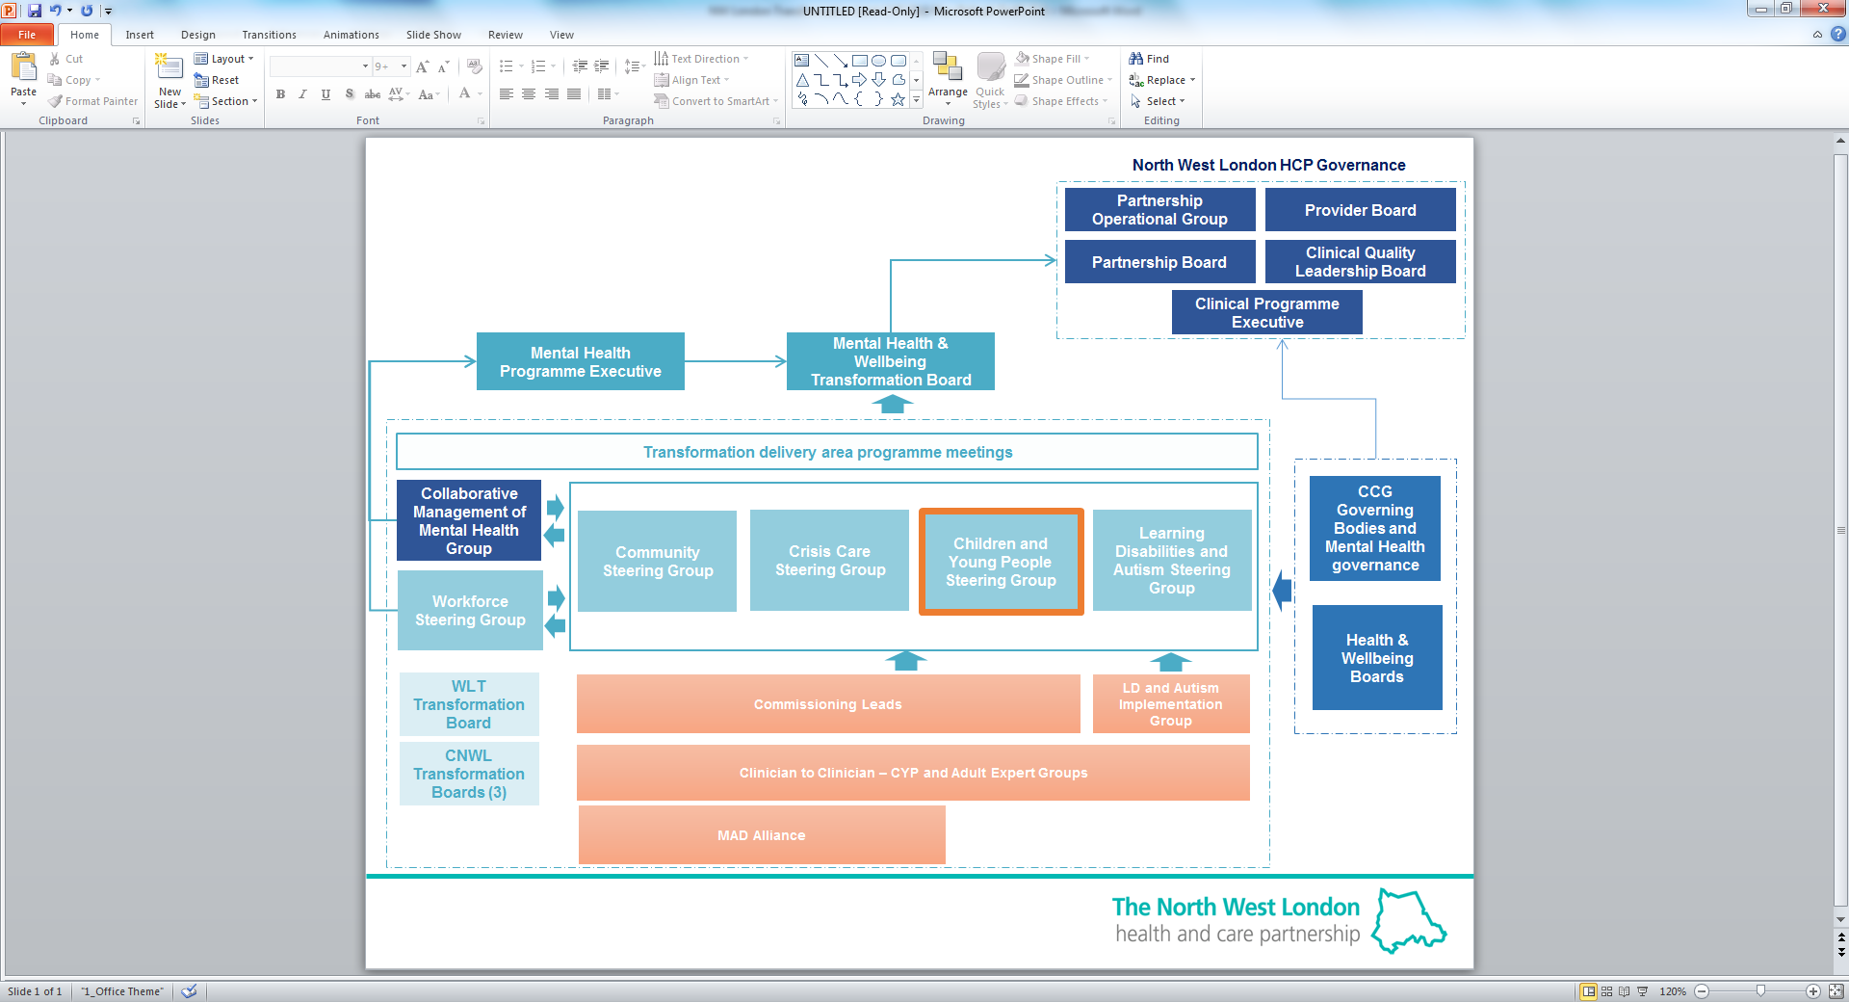

# 8. Risk Management

Key risks specific to the plan are set out below alongside the associated mitigating action.

|  |  |  |  |  |  |
| --- | --- | --- | --- | --- | --- |
| **RISK REGISTER** | | | | | |
|  | **Description** | **Impact** | **Inherent Risk Rating** | **Avoidance / Mitigation** | **Residual Risk Rating** |
| R1 | Lack of capacity and capability required to meet service requirements and implementation of new ways of working | Service delivery would be at risk due to vacancies and waiting lists would increase also impacting on the recovery of the young person. There could also be delays in implementing aspects of the new model. | 16 | A workforce strategy is in place which sets out the plans to ensure the wider CYP workforce have the right skills to deliver the right intervention at the right time.  A system wide demand and capacity modelling exercise will be undertaken in 2019/20. This exercise will inform the continued development of our transformation and workforce plans from 2020/21 onwards.  We are aligning to National HEE education and training directives and implementing designated initiatives across NW London.  Trusts are developing career pathways and identify new routes for entry into the profession. | 12 |
| R2 | Lack of accurate and timely data | Inability to understand performance and demonstrate outcome, cost and quality impact new services and new ways of working will bring. | 12 | Development of a dashboard to demonstrate current activity levels and allow for monitoring of impact of the new service delivery framework.  Work is underway to ensure  all local providers are sending data to the national reporting mechanism (MHSDS). | 5 |
| R3 | Limited buy in, capacity and engagement from other agencies e.g. education and local authority. | Difficulty developing new ways of working and new pathways | 12 | Development of a communication and engagement strategy to ensure wider sector are aware of benefits and risks of the change | 5 |
| R4 | Impact of any previous underinvestment | Additional NHS Long Term Plan funding for expanded access is predicated on previous FYFV investment having been made. Any gaps in investment would impact the starting point | 12 | Work is underway to map prior investment to provide assurance around starting point, and funding required to meet NHS Long Term Plan targets. | 5 |

# 9. Local Annexes

**ANNEX A: Brent CCG** (attached as a separate document)

**ANNEX B: Central London CCG** (attached as a separate document)

**ANNEX C: Ealing CCG** (attached as a separate document)

**ANNEX D: Hammersmith and Fulham CCG** (attached as a separate document)

**ANNEX E: Harrow CCG** (attached as a separate document)

**ANNEX F: Hillingdon CCG** (attached as a separate document)

**ANNEX G: Hounslow CCG** (attached as a separate document)

**ANNEX H: West London CCG** (attached as a separate document)

1. [NW London Sustainability and Transformation Plan](https://www.healthiernorthwestlondon.nhs.uk/sites/nhsnwlondon/files/documents/nwl_stp_october_submission_summary_v01.pdf) November 2016
2. [NHS Long Term Plan 2019](https://www.longtermplan.nhs.uk/publication/nhs-long-term-plan/)
3. [Like Minded Case for Change](https://www.healthiernorthwestlondon.nhs.uk/news/2015/08/18/minded-case-change) 2015
4. National Statistics [Special educational needs in England](https://www.gov.uk/government/statistics/special-educational-needs-in-england-january-2019): January 2019. Local authority tables: Table 12
5. Office for National Statistics, [Mid 2017 dataset](https://www.ons.gov.uk/peoplepopulationandcommunity/populationandmigration/populationestimates/datasets/populationestimatesforukenglandandwalesscotlandandnorthernireland)
6. 4 Office for National Statistics, [Mid 2017 dataset](https://www.ons.gov.uk/peoplepopulationandcommunity/populationandmigration/populationestimates/datasets/populationestimatesforukenglandandwalesscotlandandnorthernireland)

   Health London Partnership – Executive Mental Health Dashboard for London
7. # Public Health England Fingertips [Children and Young People’s Mental Health and Wellbeing](https://fingertips.phe.org.uk/profile-group/mental-%20health/profile/cypmh/data#page/1/gid/1938133090/pat/120/ati/153/are/E38000020)

  
8. Mental Health Foundation – [self harm](htps://www.mentalhealth.org.uk/a-to-z/s/self-harm) 
9. Public Health Profiles – [Looked After Children where there is a cause for concern](https://fingertips.phe.org.uk/search/looked%20after%20children)
10. National Statistics, [Special educational needs in England: January 2018](https://www.gov.uk/government/statistics/special-educational-needs-in-england-january-2018) Local authority tables: SFR37/201
11. Public Health England, [Children and Young People’s Mental Health and Wellbeing](https://fingertips.phe.org.uk/cypmh#page/0/gid/1938133096/pat/6/par/E12000007/ati/102/are/E09000005/iid/10401/age/211/sex/4)
12.
13. Anna Freud National Centre for Children and Families [THRIVE Framework](https://www.annafreud.org/what-we-do/improving-help/thrive-framework/) 
14. Drawing on the Evidence (Second Edition), Wolpert, Fuggle, Cottrell et al. (2006) CAMHS Publications
15. The numbers reported here are staff currently retained from previous waves of training.